

DistroKids

Changes Document

Reatlegile Sibanda ST10229185 Jordan Leafe ST10088204 Mokwena Menyatso ST100885 Andile Motshweni ST10179900

Table of Contents

Introduction 2

Feedback from Client 2

Updates to the Project Plan 3

Additional Features in the WBS 7

Splash Screen 8

Milestone and Deliverables Adjusted 9

Economic/Budget Changes 10

Use Case Diagram Updates 13

Diagram 1: Website Use Case 13

Diagram 2: Application Use Case 14

Diagram 3: Application Use Case (admin) 14

ERD Changes 15

High Level Architectural Design Updates 16

Low Level Architectural Design Updates 18

Database Tables Reflect Database Changes 20

Solution Domain Update 21

New Website Specifications 22

New Application Specifications 23

Website Mockups Updated to Reflect Current Design 24

App Mockups Updated to Reflect Current Design 27

Redone Project Brief 29

Azure DevOps implementation 31

GitHub implementation 40

# **Introduction**

Throughout the development of our POE project for XISD, we encountered several alterations that needed to be integrated into our documentation. This document details all the revisions that were essential for updating our semester 1 documentation in preparation for the final semester 2 documentation.

# **Feedback from Client**

The client's communications resulted in various adjustments being made.

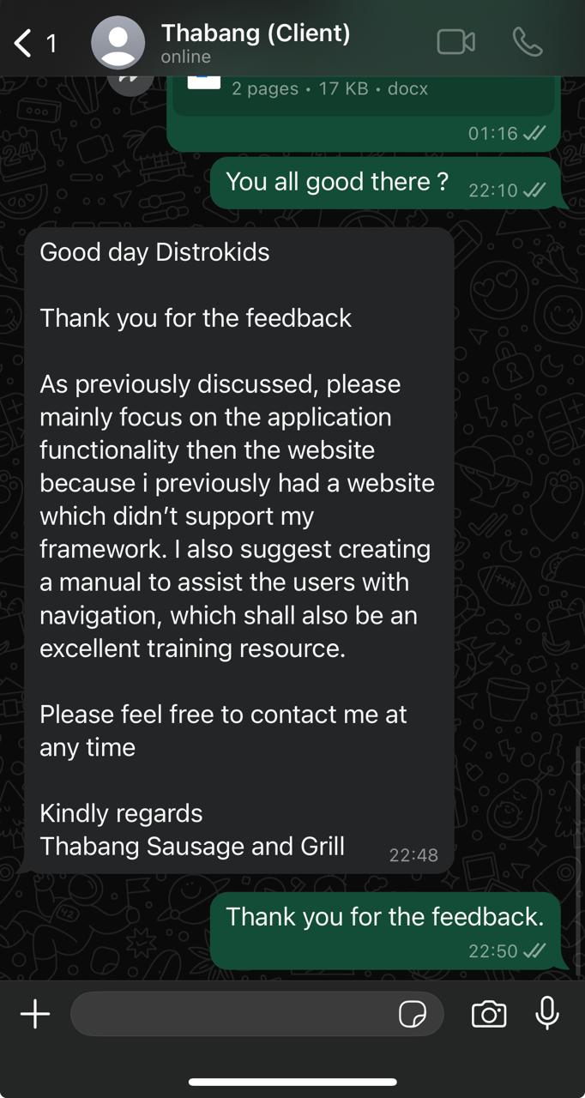

# **Updates to the Project Plan**

The coding for the website, along with the project's final phases, is now addressed within the revised and comprehensive project plan.









# **Additional Features in the WBS**

The modifications and newly incorporated features were documented in both the project plan and the Work Breakdown Structure (WBS).

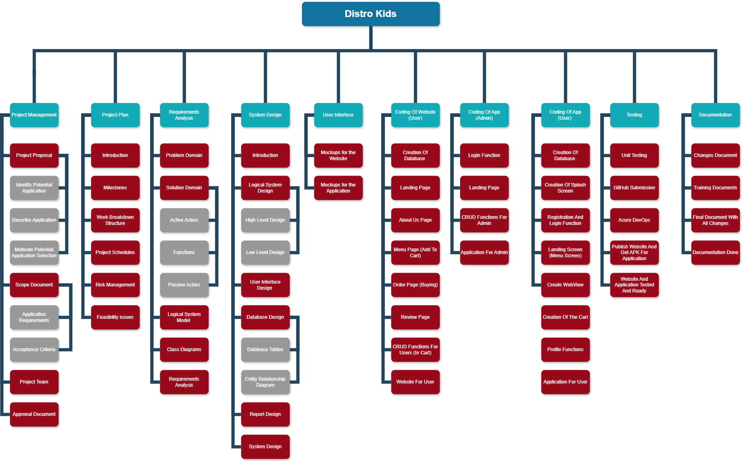

# **Splash Screen**

In response to user feedback, we have implemented a splash screen that appears prior to the landing page. This modification eliminates the need for users to press a button to proceed, which can be time-consuming for some. The splash screen will display during the initial loading of the application, fostering a sense of anticipation and excitement.

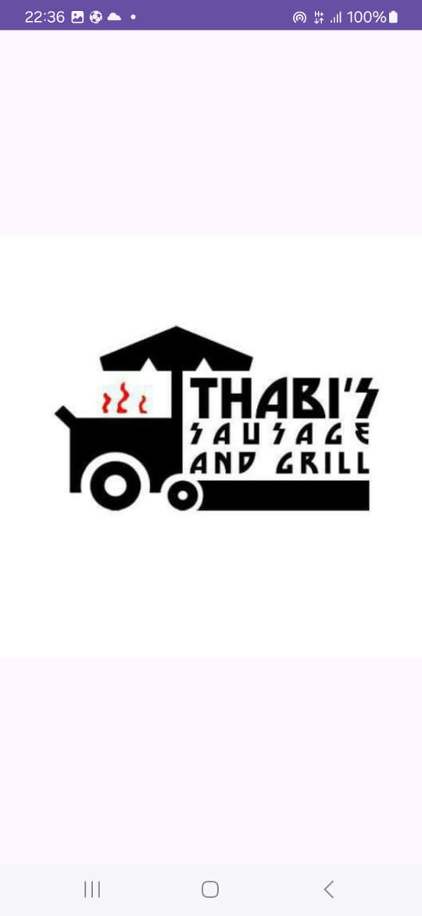

# **Milestone and Deliverables Adjusted**

Due to evolving project requirements, milestones and deliverables have been adjusted for consistency. The project’s key milestones and deliverables are as follows:

|  |  |
| --- | --- |
| **Milestones** | **Deliverables** |
| 1. **Approval Document** | Project proposal, scope document |
| 1. **Project Initiation** | Deliverables: Project charter, stakeholder analysis, requirements specification document, feasibility report, initial risk assessment. |
| 1. **Requirement analysis** | Problem domain, solution domain, class diagrams |
| 1. **Design and Prototyping** | Deliverables: UI/UX mock-ups, app architecture and design specifications, working prototype, prototype test plan. |
| 1. **System Design** | Logical architectural design, user interaction design, database design |
| 1. **Development Phases** | Coding of website(user),application (user and admin)  Alpha Version: Internal app testing, test reports, updated risk assessment. |
| 1. **Launch Preparation** | Deliverables: Final app version, ASO materials, launch marketing plan, training sessions, customer support setup. |
| 1. **App Launch and Post-Launch** | Deliverables: Launch event, customer feedback report, update roadmap |
| 1. **Documentation** | All documentation done |
| 1. **Growth and Scaling** | Deliverables: New feature updates, user feedback survey on features. |

# **Economic/Budget Changes**

Changes required budget estimations

|  |  |  |  |  |
| --- | --- | --- | --- | --- |
| **Task Identification** | **Team member(s)**  **responsible** | **Time allocated per task per team member** | **Tariff per team member in Rand per hour** | **Cost per task**  (time * tariff) |
| **Project Management** |  |  |  | **R11,220** |
|  |  |  |  |  |
| Project Proposal | Jordan, Mokwena, Andile | 2 hours each | R700/hour | R4,200 |
| Scope Document | Jordan, Andile and Reatlegile | 2 hours each | R700/hour | R4,200 |
| Project Team Setup | Mokwena, Andile and Reatlegile | 1 hours each | R940/hour | R2,820 |
|  |  |  |  |  |
| **Project Plan** |  |  |  | **R10,700.00** |
| Introduction | Jordan and Reatlegile | 1 hours each | R400/hour | R800.00 |
| Milestones and Deliverables | Jordan and Mokwena | 3 hours each | R150/hour | R900.00 |
| Work Breakdown Structure (WBS) | Andile and Mokwena | 3 hours each | R200/hour | R1,200.00 |
| Project Schedules | Jordan and Reatlegile | 2 hours each | R525/hour | R2,100.00 |
| Risk Management | Reatlegile and Andile | 4 hour | R400/hour | R3,200.00 |
| Technical Feasibility Issues | Andile | 5 hour | R250/hour | R1,250.00 |
| Economic Feasibility Issues | Mokwena | 5 hour | R250/hour | R1,250.00 |
|  |  |  |  |  |
| **Analysis** |  |  |  | **R13,800** |
| Problem Domain | Jordan | 1 hours each | R150/hour | R300.00 |
| Solution Domain | Andile | 1 hours each | R150/hour | R300.00 |
| Logical System Model | Mokwena and Reatlegile | 6 hours each | R800/hour | R9,600.00 |
| Class Diagrams | Andile and Jordan | 2 hours each | R900/hour | R3,600.00 |
|  |  |  |  |  |
| **System Design** |  |  |  | **R12,400** |
| Introduction | Jordan and Reatlegile | 1 hours each | R400/hour | R800.00 |
| Logical architectural design | Mokwena and Jordan | 4 hours each | R300/hour | R2,400.00 |
| User interaction design | Mokwena and Andile | 5 hours each | R500/hour | R5,000.00 |
| Database Design | Jordan and Reatlegile | 2 hours each | R250/hour | R1,000.00 |
| Design Report | Jordan and Reatlegile | 4 hours each | R400/hour | R3,200.00 |
|  |  |  |  |  |
| **User Interface** |  |  |  | **R12,000** |
| Mock ups for the android | Andile,Jordan,Mokwena and Reatlegile | 3 hours each | R500/hour | R6000.00 |
| Mock ups for the website | Andile,Jordan,Mokwena | 2 hours each | R500/hour | R3000.00 |
| Application and Website mock ups | Jordan,Mokwena and Reatlegile | 2 hours each | R500/hour | R3000.00 |
|  |  |  |  |  |
| **Website Development for (Client-End)** |  |  |  | **R30,000** |
| Coding | Andile,Jordan,Mokwena and Reatlegile | 5 hours each | R1000/hou | R20,000 |
| Testing | Andile,Jordan,Mokwena and Reatlegile | 4 hours each | R625/hour | R10,000 |
|  |  |  |  |  |
| **Android Development for (Admin-End)** |  |  |  | **R20,000.00** |
| Coding | Andile,Jordan,Mokwena and Reatlegile | 3 hours each | R1250/hr | R15,000.00 |
| Testing | Andile,Jordan,Mokwena and Reatlegile | 1 hours each | R1250/hr | R5,000.00 |
|  |  |  |  |  |
| **Android Development for (Client-End)** |  |  |  | **R65,000.00** |
| Coding | Andile,Jordan,Mokwena and Reatlegile | 10 hours each | R1250 | R50,000 |
| Testing | Andile,Jordan,Mokwena and Reatlegile | 5 hour each | R750 | R15,000 |
|  |  |  |  |  |
| **Publishing** |  |  |  | **R300** |
| Publishing to Azure Board | Reatlegile | 1 hour each | R300 | R300 |
|  |  |  |  |  |
| **Documentation** |  |  |  | **R1200** |
| Collecting and creating a PowerPoint Presentation | Reatlegile and Andile | 2 hours each | R300 | R1200 |
| **Total Budget For Project** |  |  |  | R165,800.00 |

# **Use Case Diagram Updates**

In light of the enhancements made to the mobile Android and web browser versions of the application, the Use Case Diagrams have been revised to incorporate the latest user scenarios. Furthermore, the functions have been adjusted to correspond with the newly designed layout.

## **Diagram 1: Website Use Case**

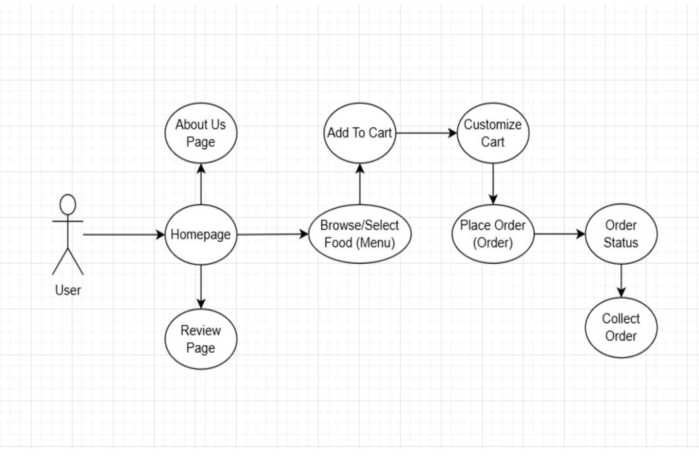

## **Diagram 2: Application Use Case**

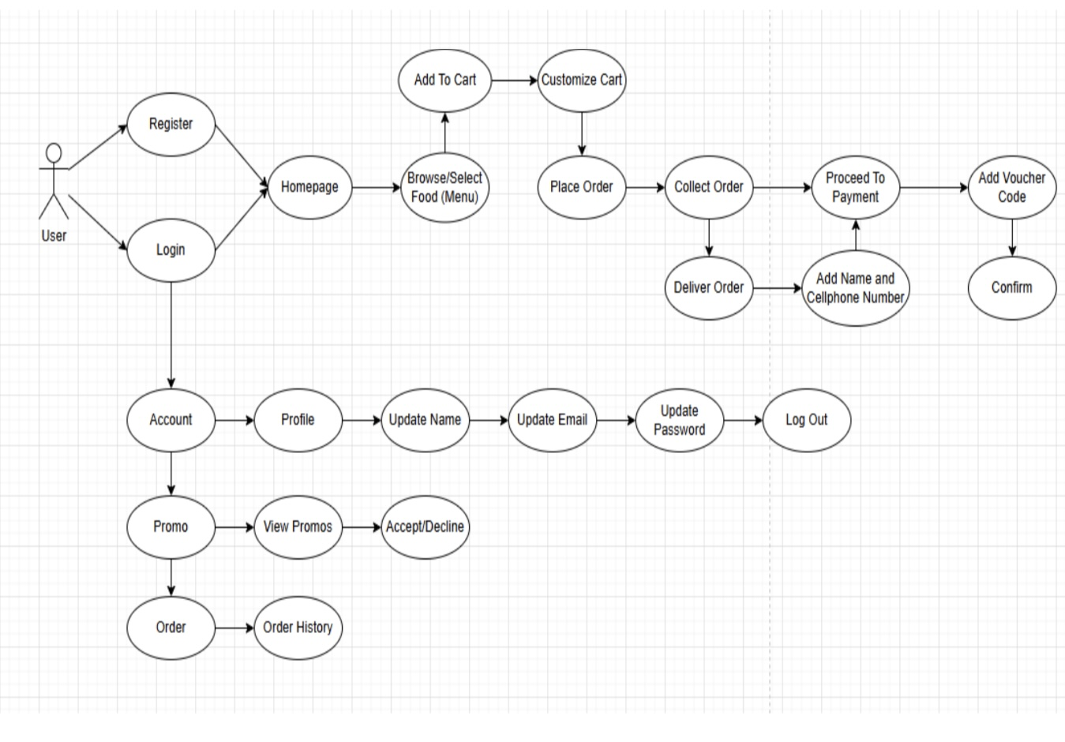

## **Diagram 3: Application Use Case (admin)**

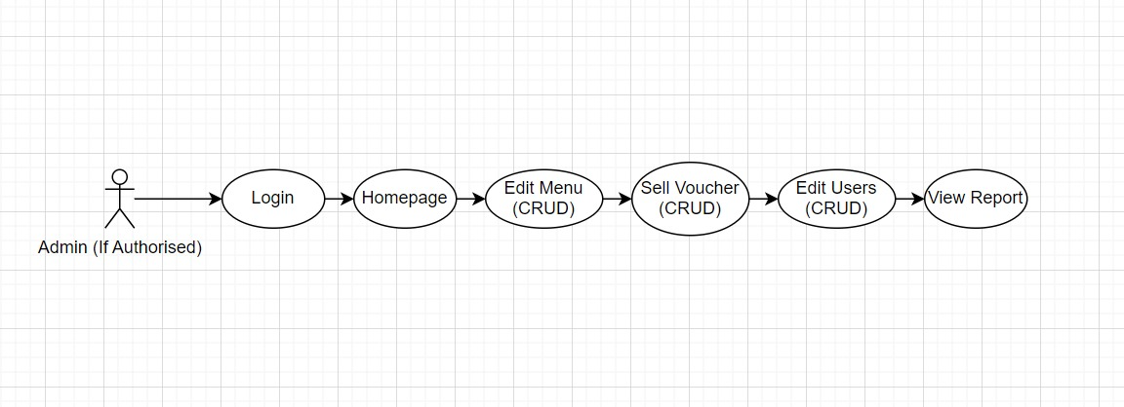

# **ERD Changes**

As a result of database changes, the Entity Relationship Diagram needed updating.

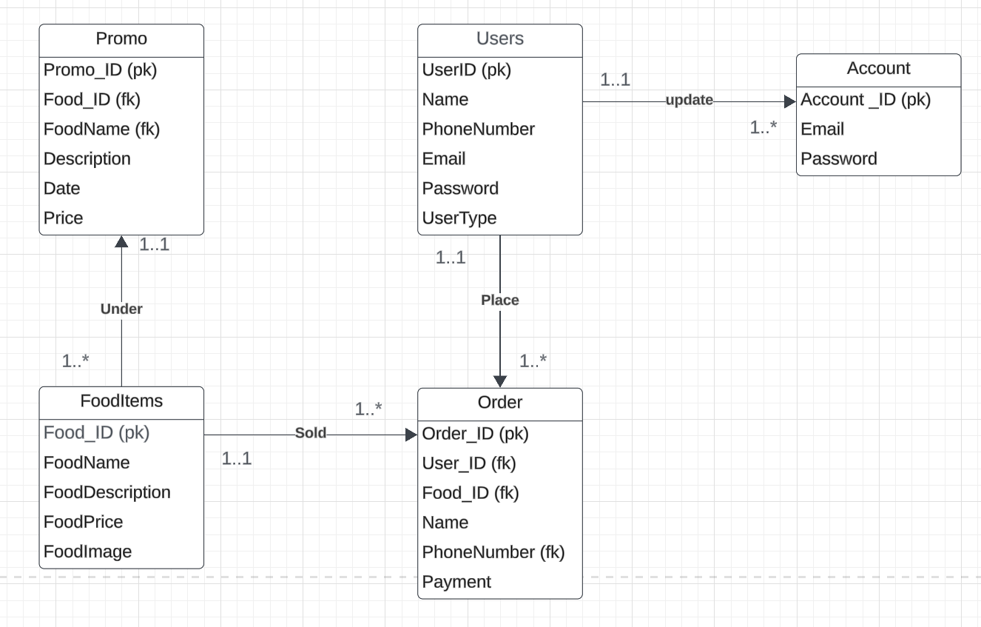

# **High Level Architectural Design Updates**

Modifications have been made to the high-level diagrams to align with changes in the database and to better represent user use cases.

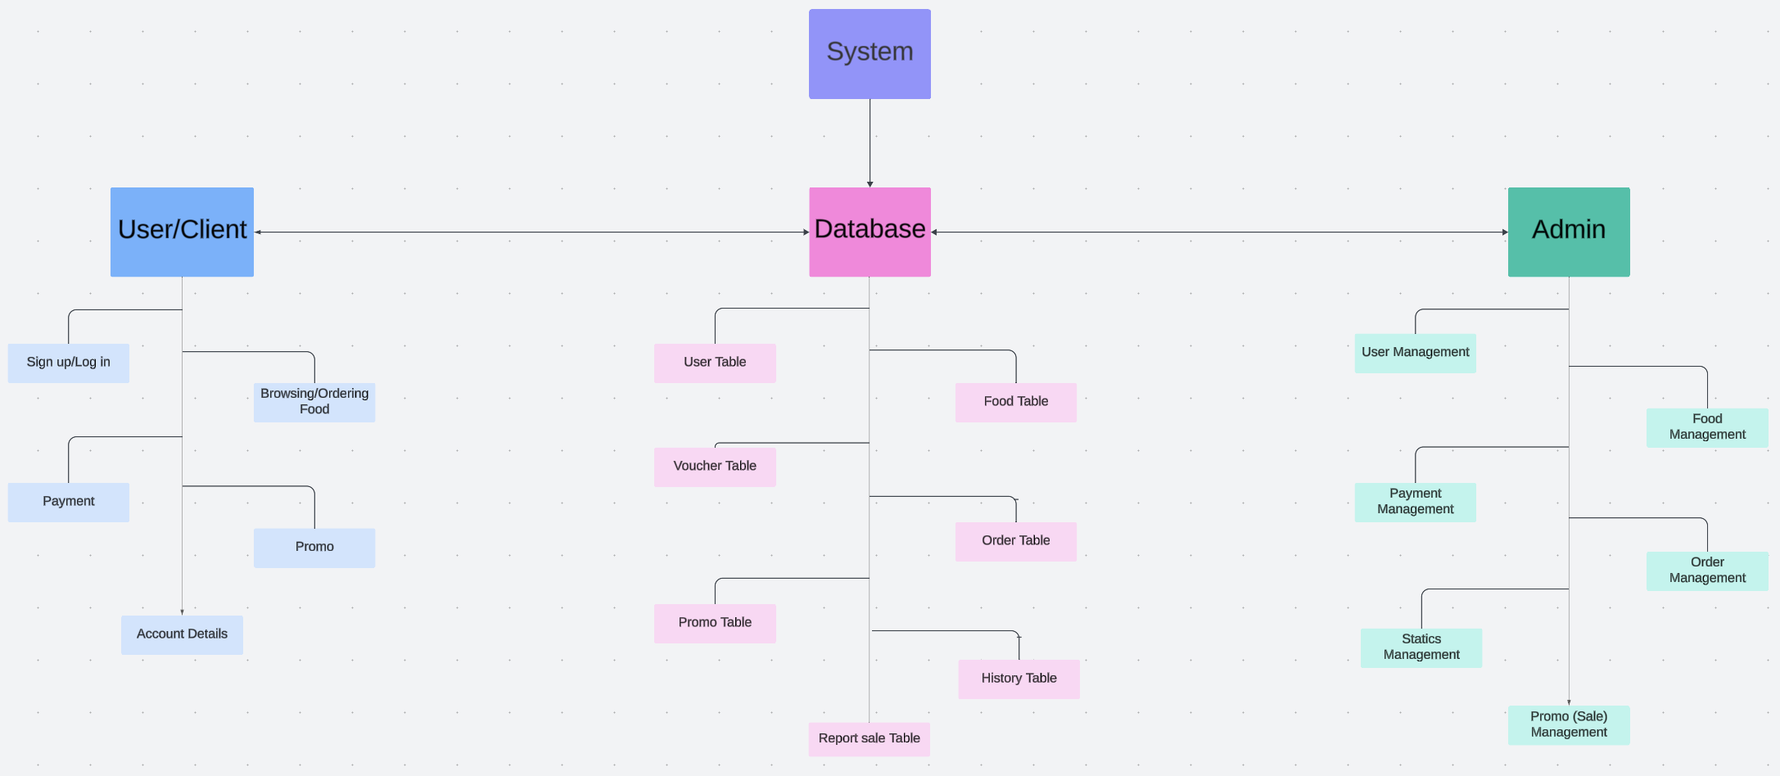

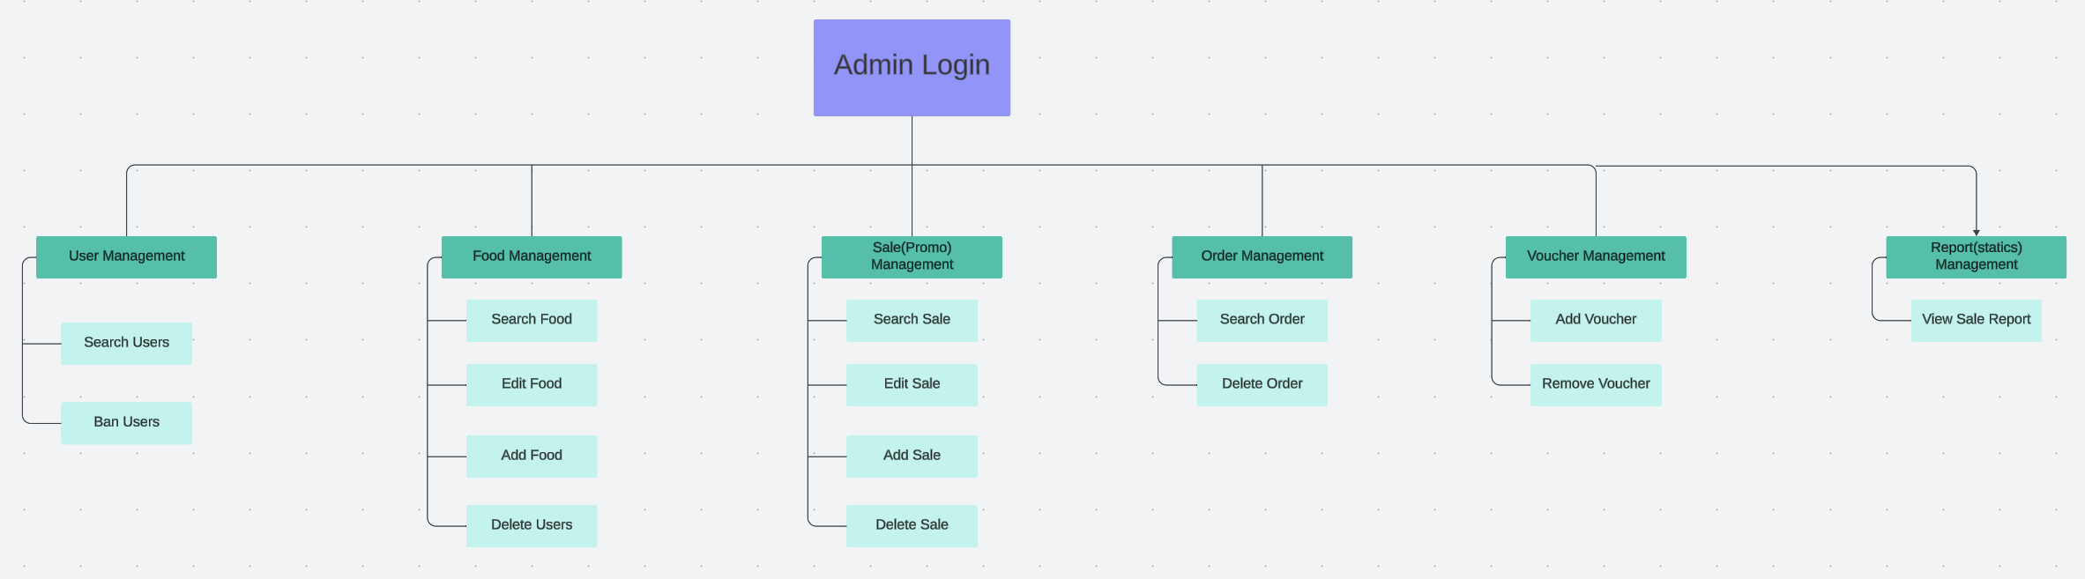

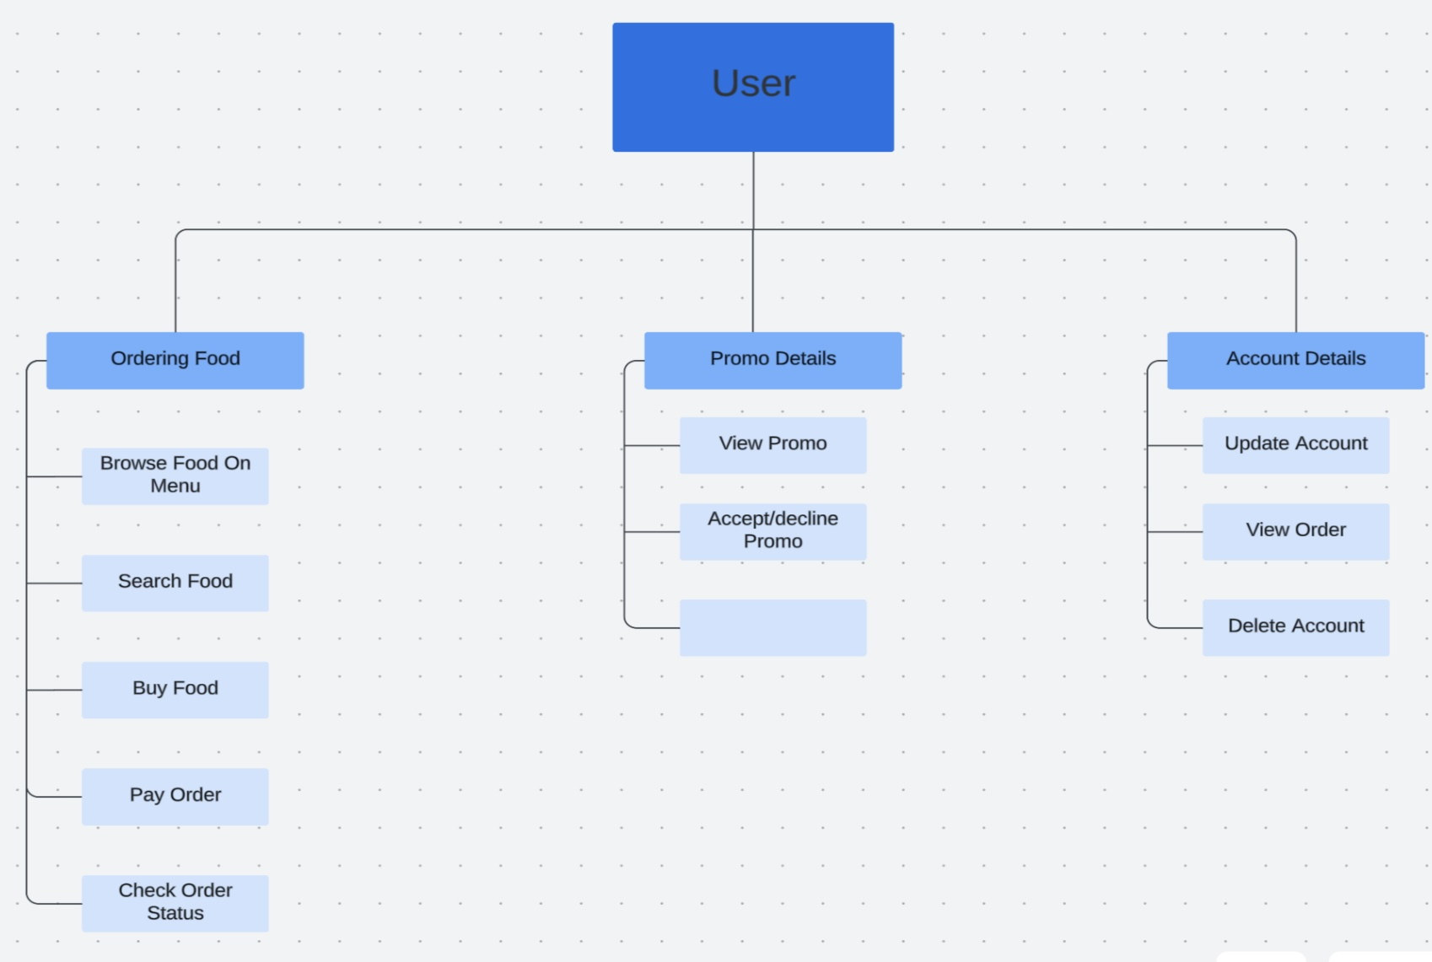

# **Low Level Architectural Design Updates**

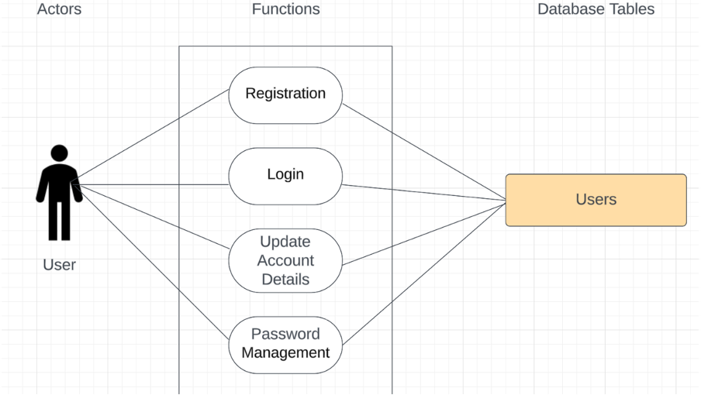

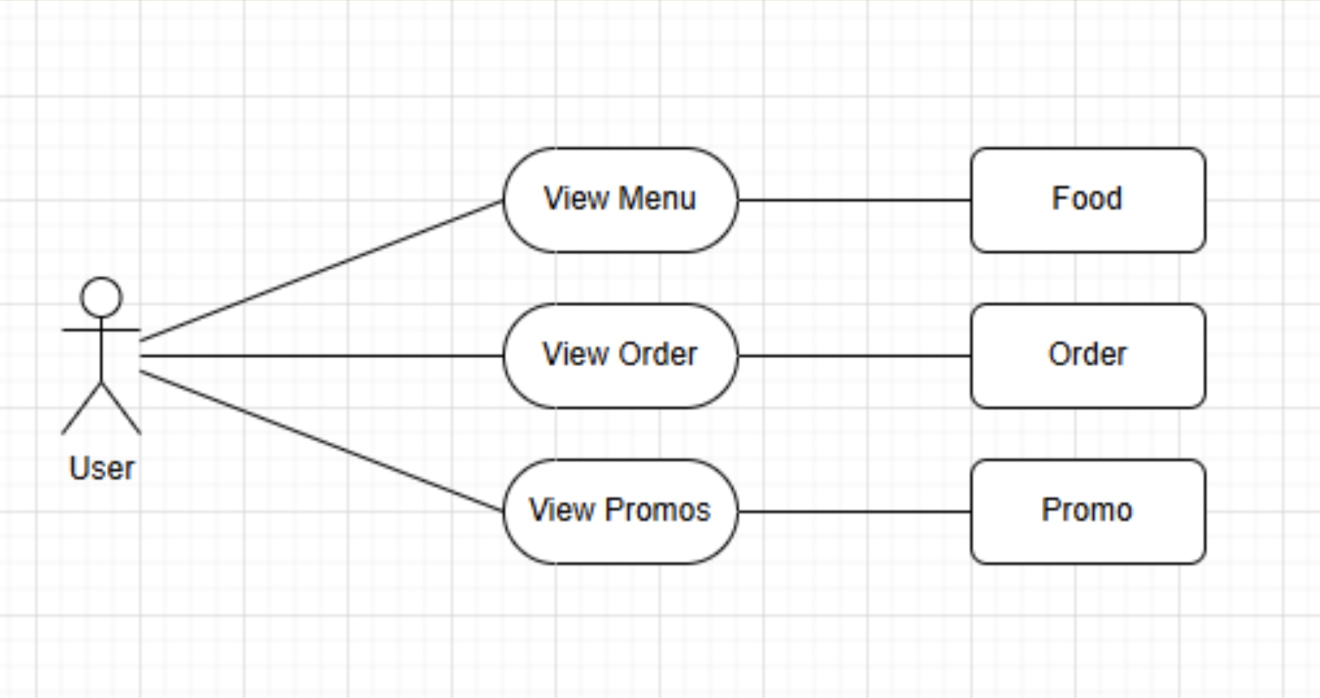

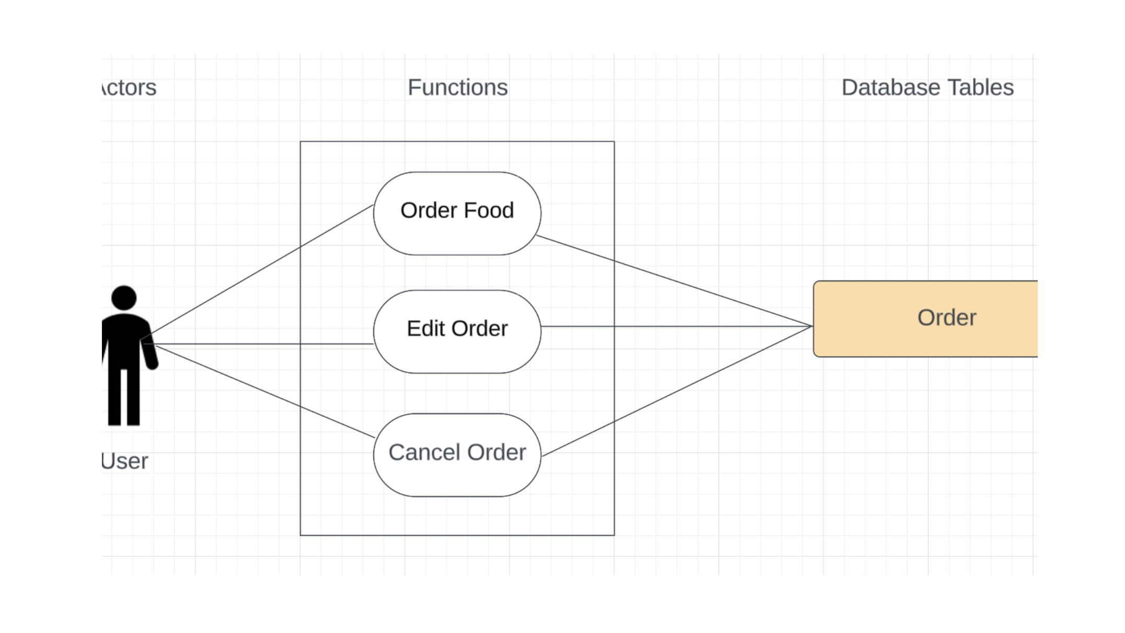

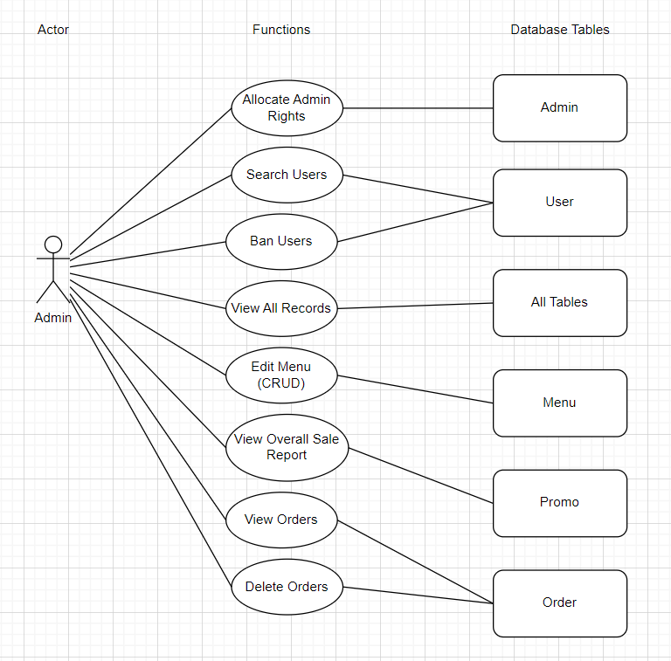

# Database Tables Reflect Database Changes



# **Solution Domain Update**

|  |  |
| --- | --- |
| **System Process (Method)** | **Entity Relationship (Table)** |
| Account Creation | User Table |
| User Login | User Table |
| Display Menu Items | Menu Table |
| Place Order | Order Table, Menu Table |
| Track Order | Order Table |
| Display Promo | Promo (sale) Table |
| Update Account | User Table |
| Admin Login | Admin Table |
| Manage Menu | Menu Table |
| Manage Orders | Order Table |
| Manage Users | User Table |
| View Reports | Report Table, Order Table |
| Update Profile (admin) | Admin Table |
| View Order History | Order Table |

# **New Website Specifications**

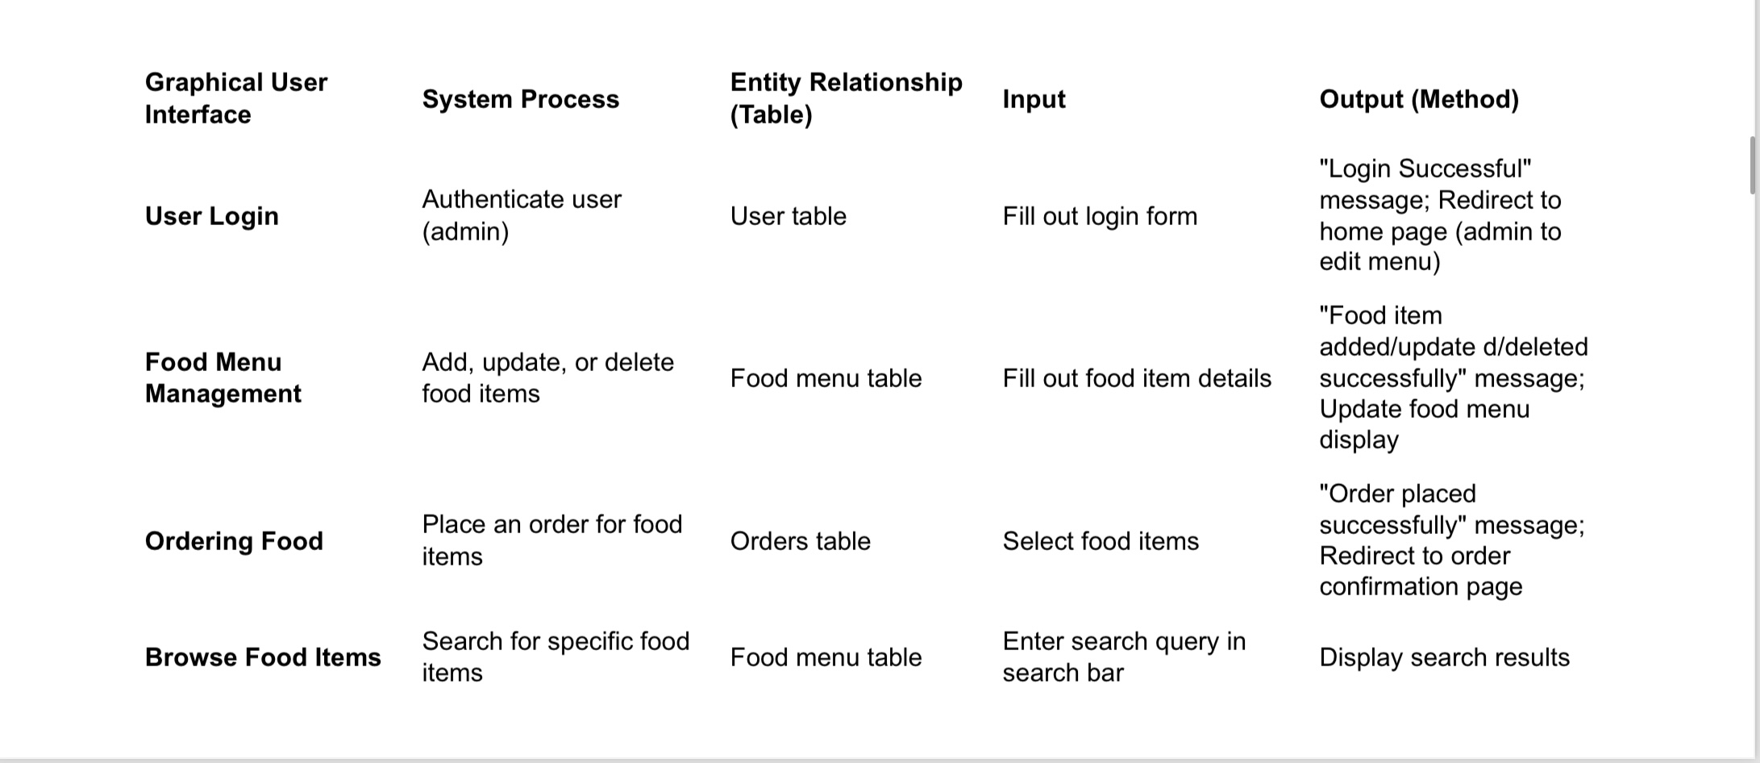

# **New Application Specifications**

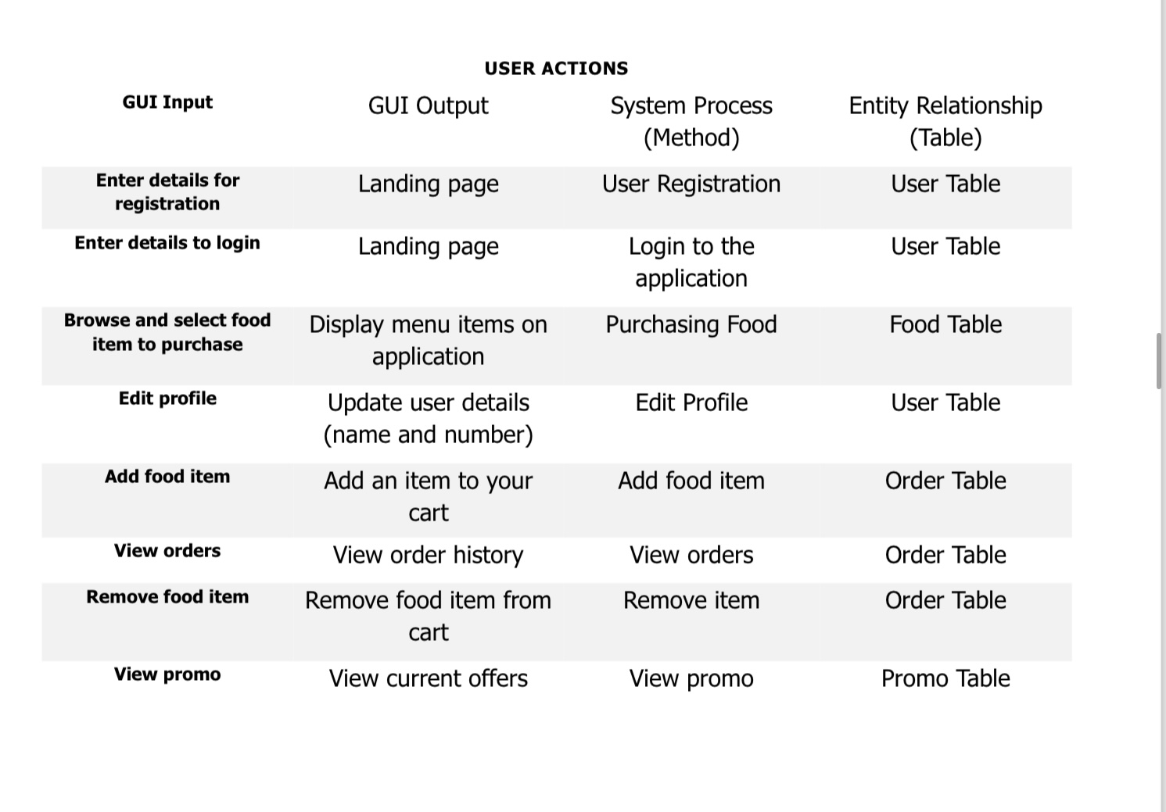

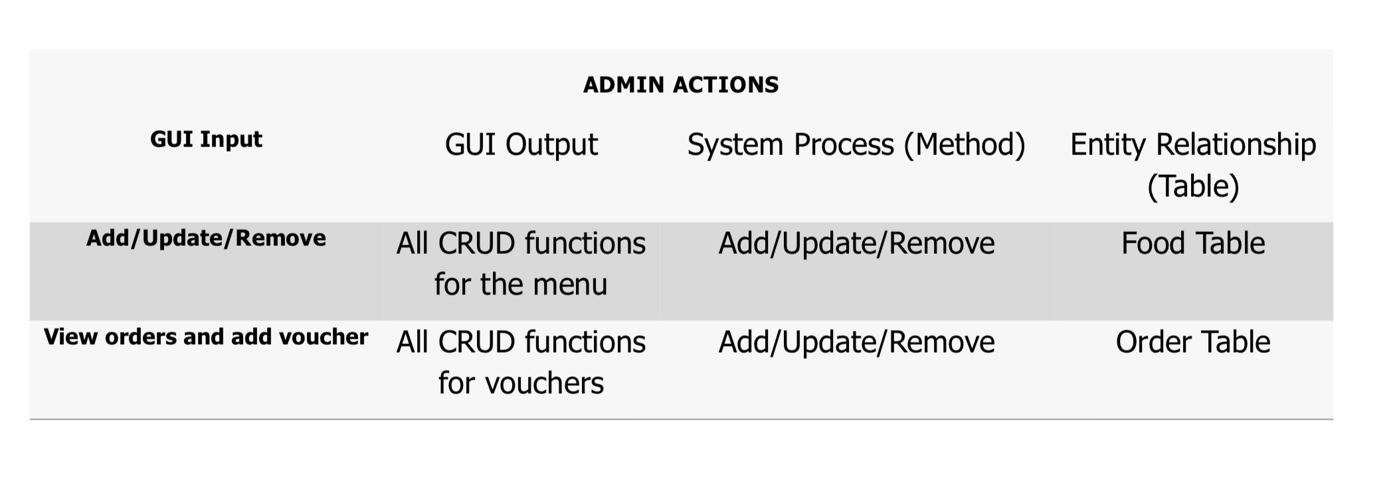

|  |  |
| --- | --- |
| **System Process** | |
| **System Process (method)** | **Entity Relationship (table)** |
| Password Encryption | UserTable |
| User Authentication and Authorization | UserTable |
| Analytics and Insights | System Analytics Table |

# **Website Mockups Updated to Reflect Current Design**

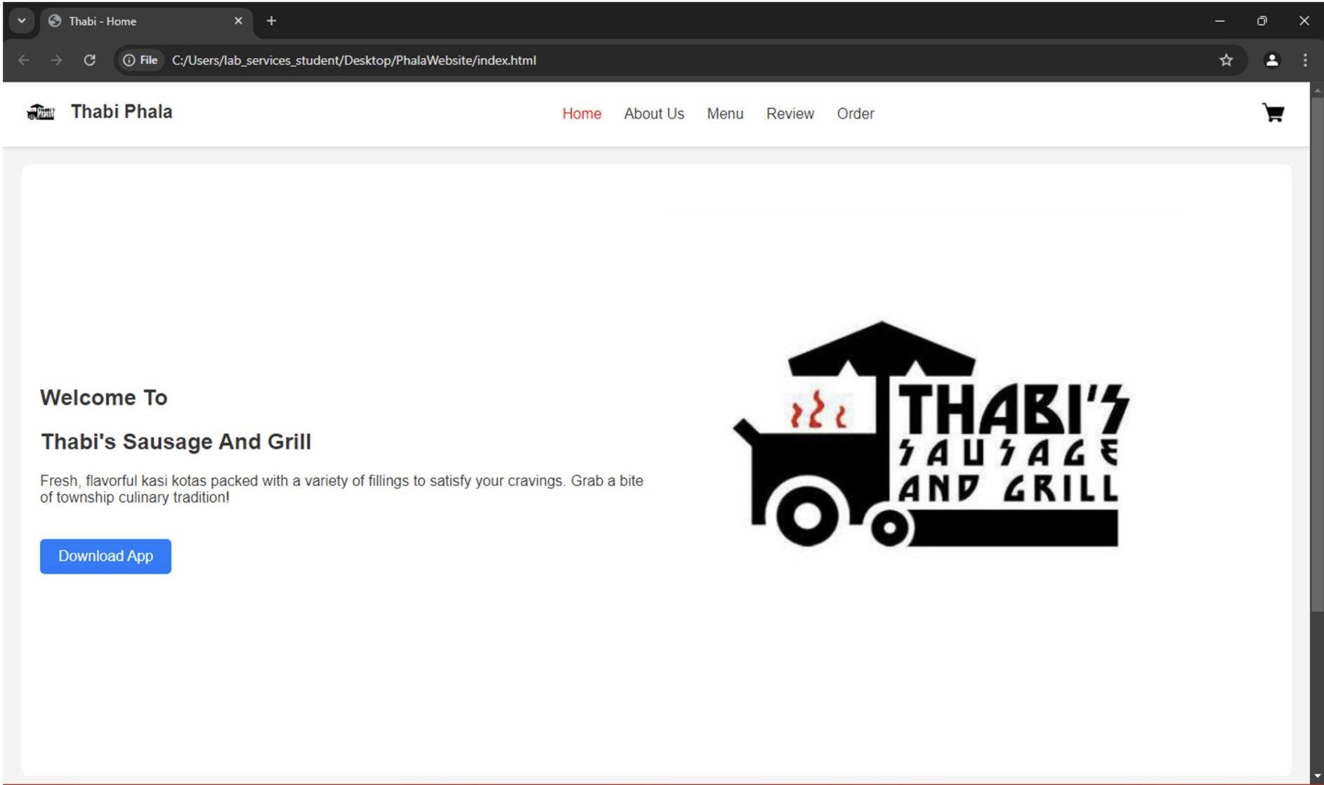

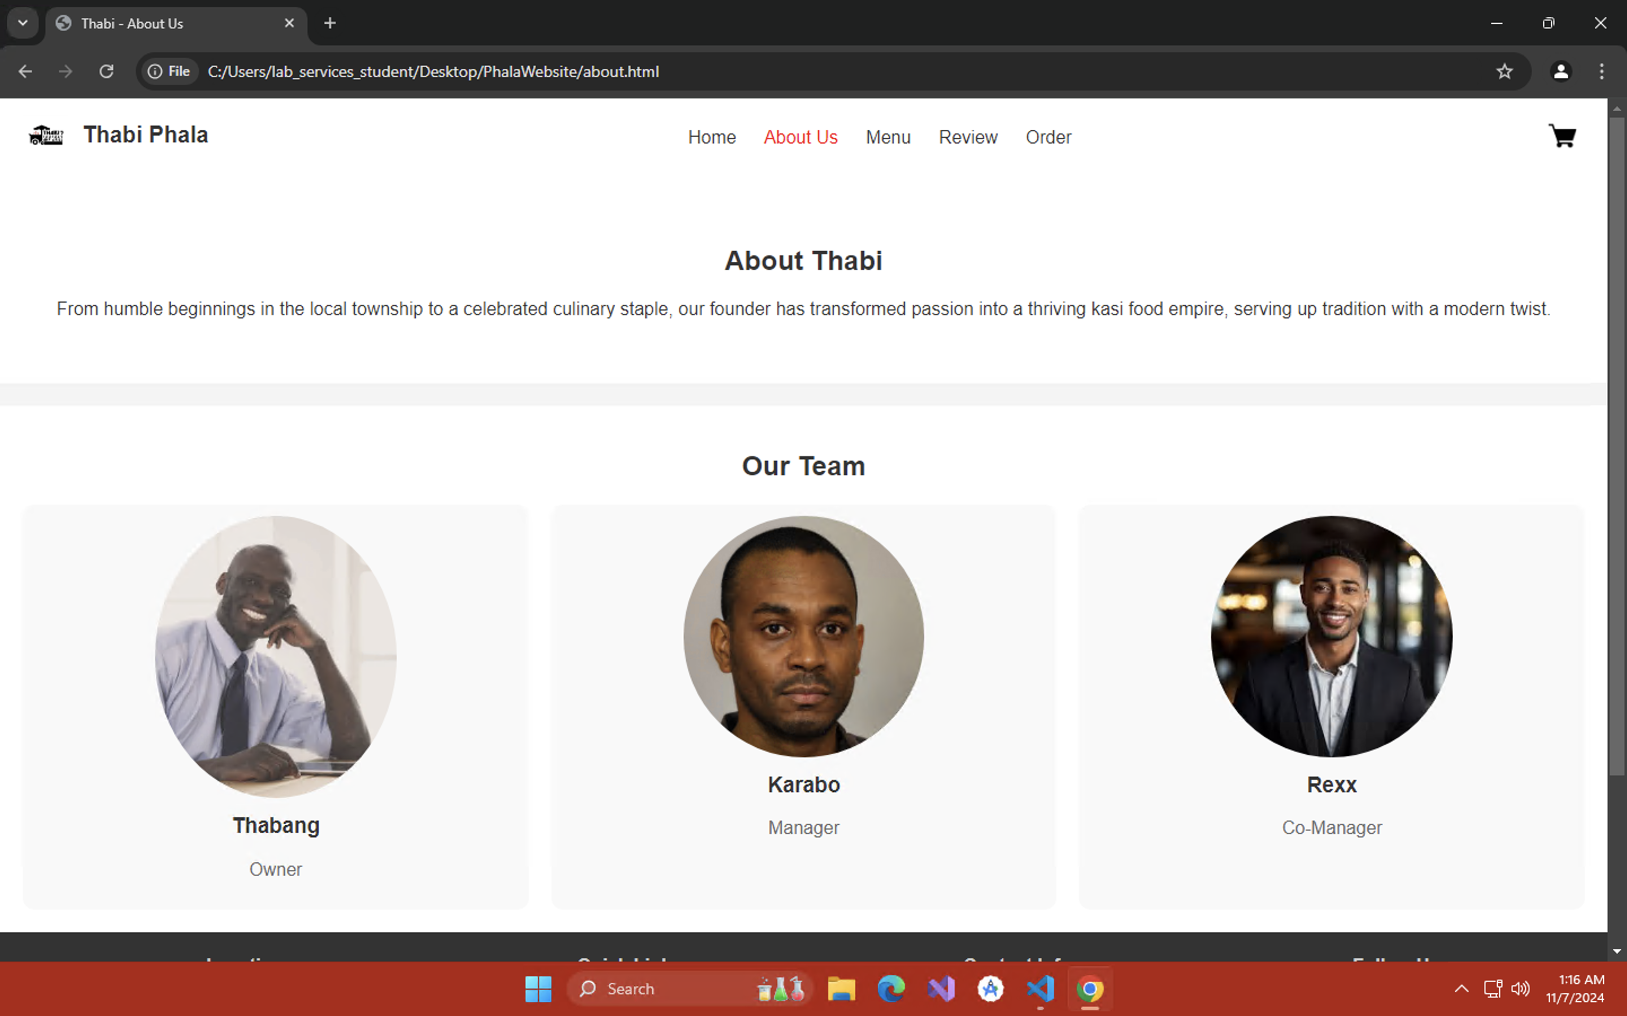

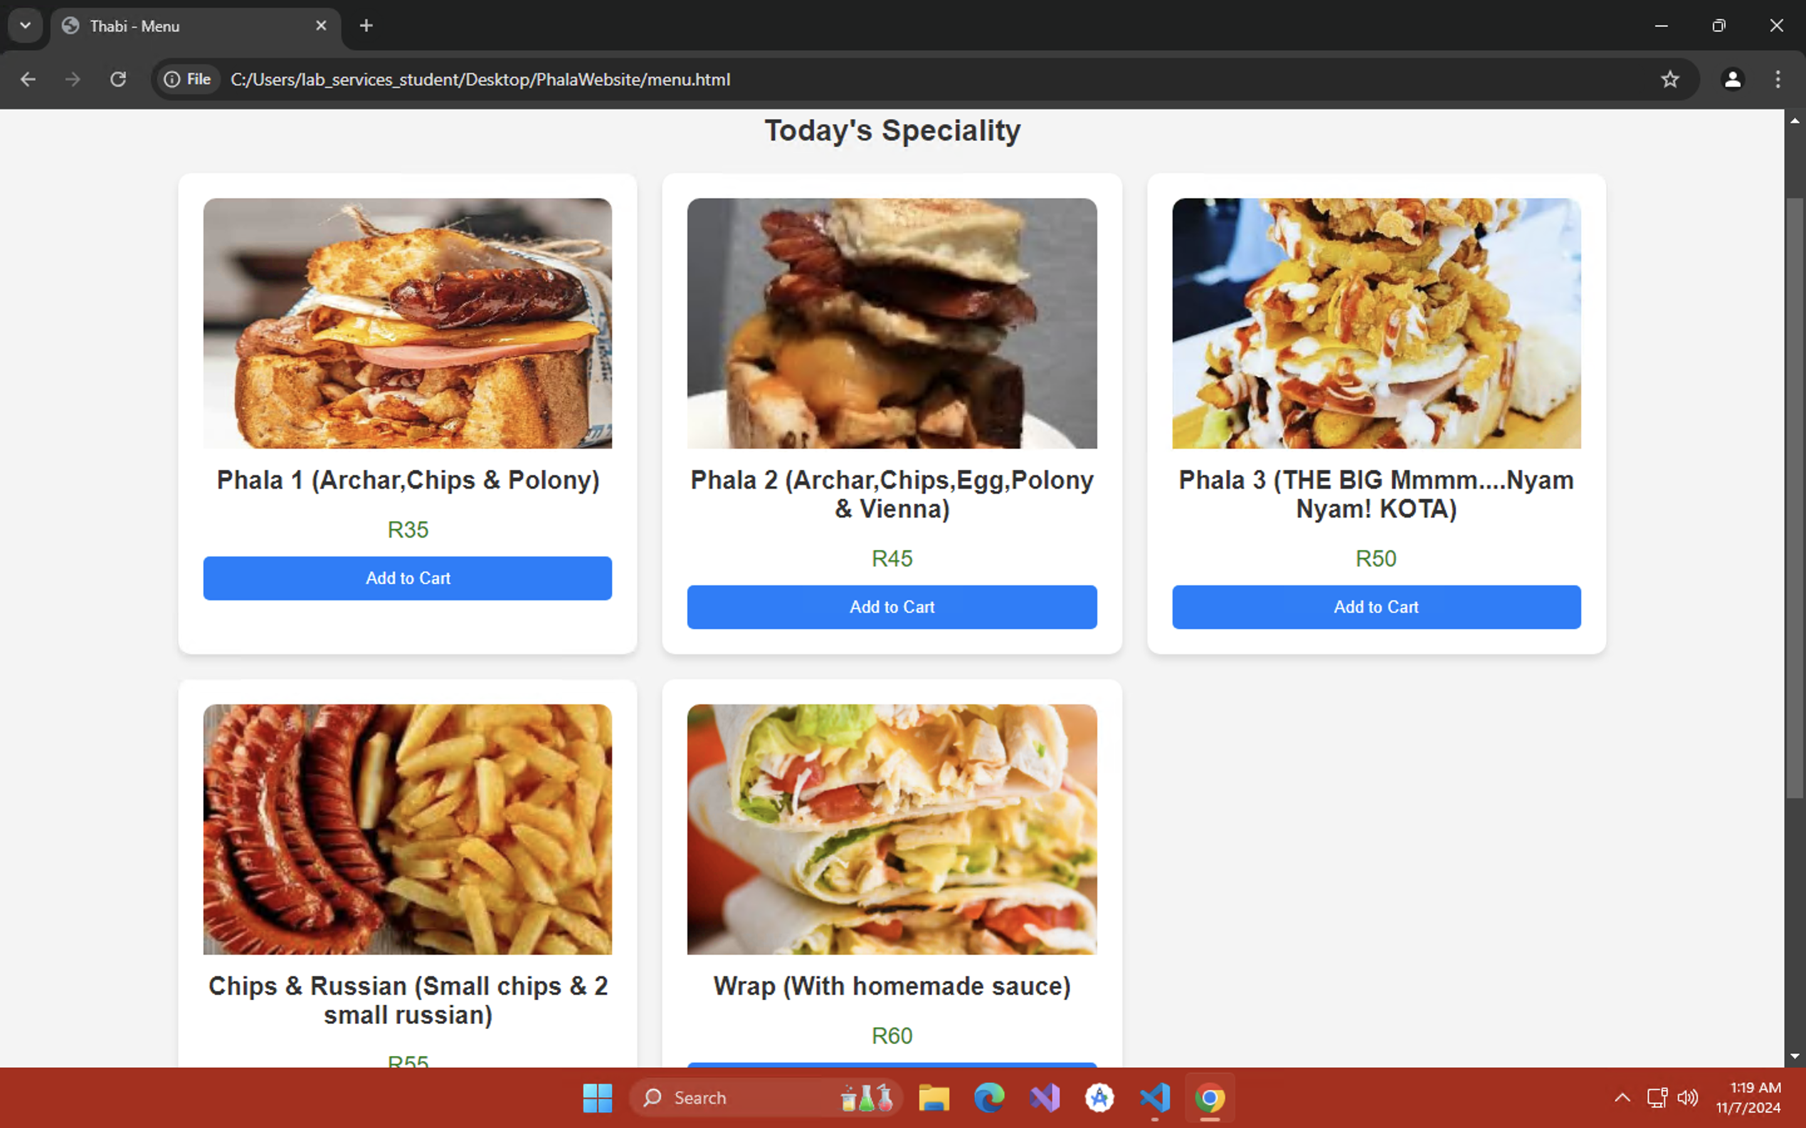

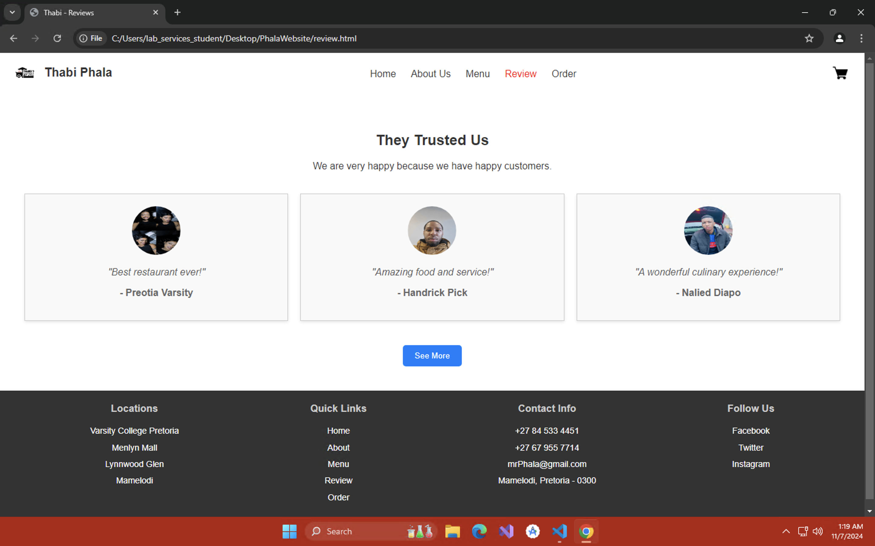

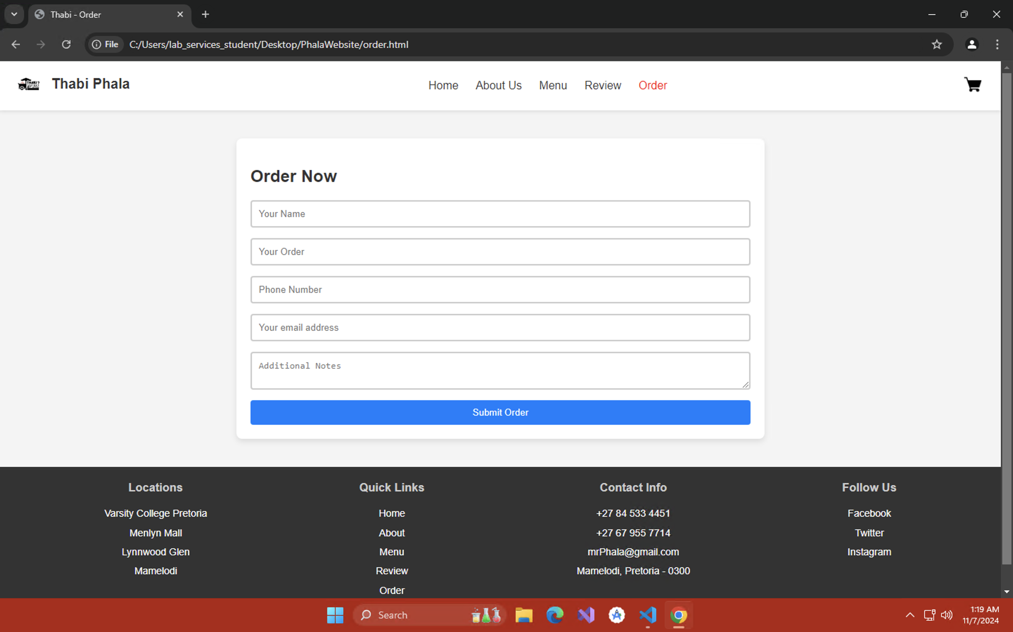

# **App Mockups Updated to Reflect Current Design**

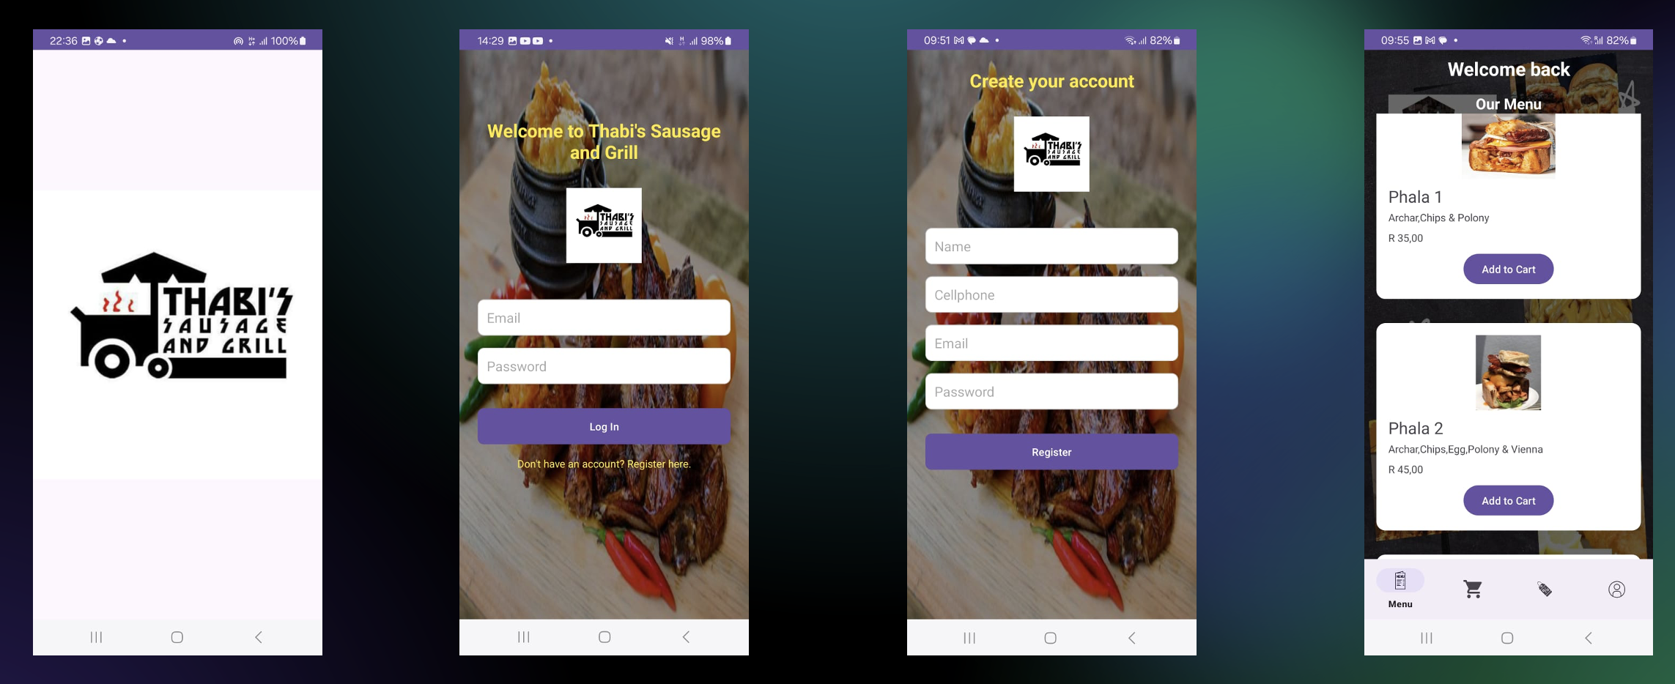

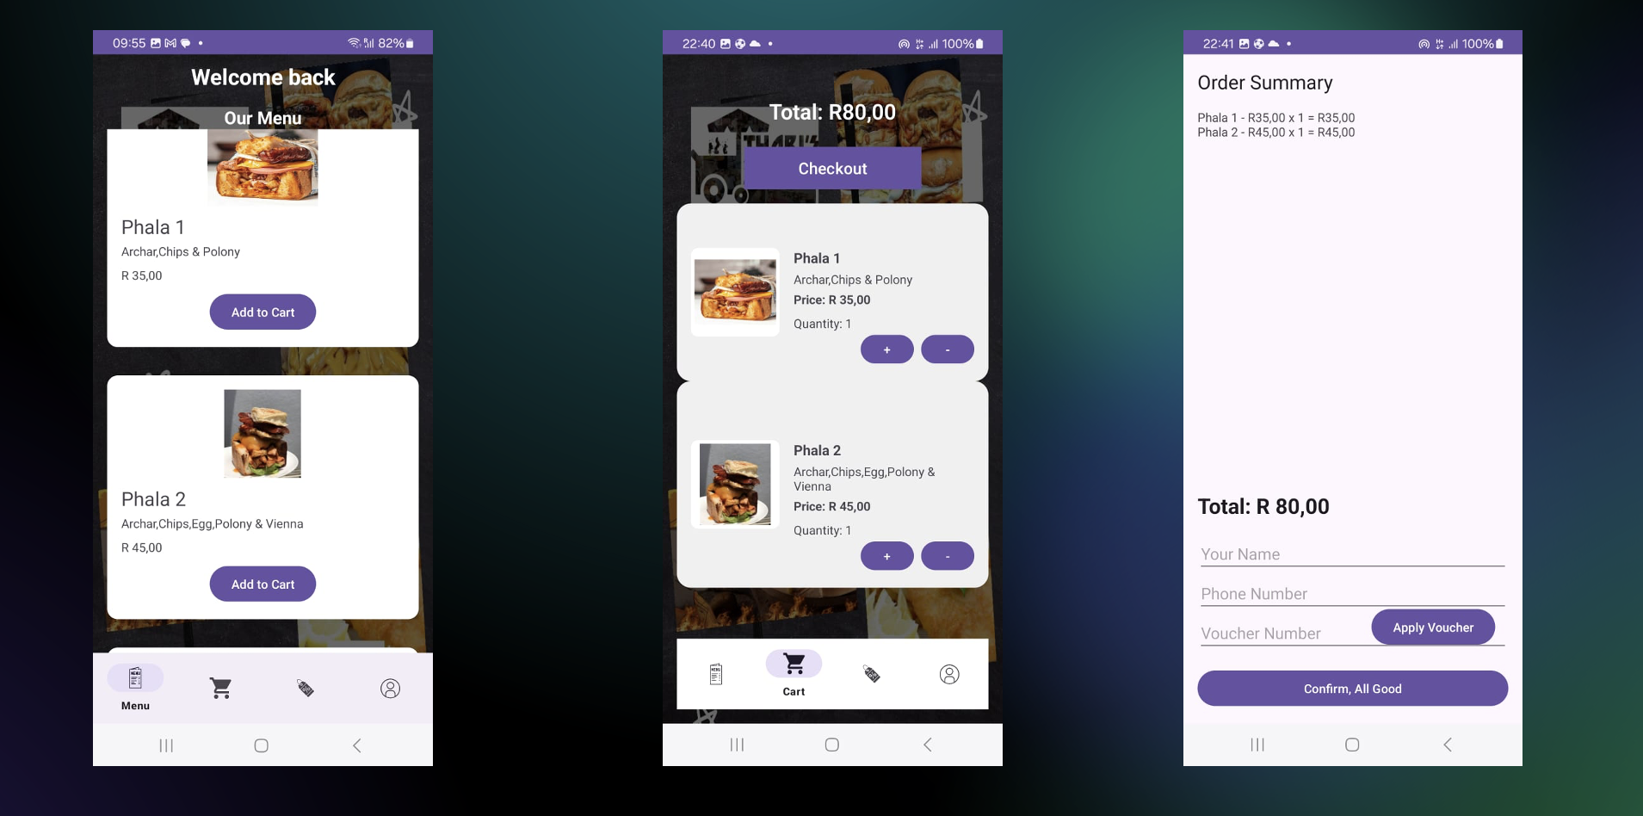

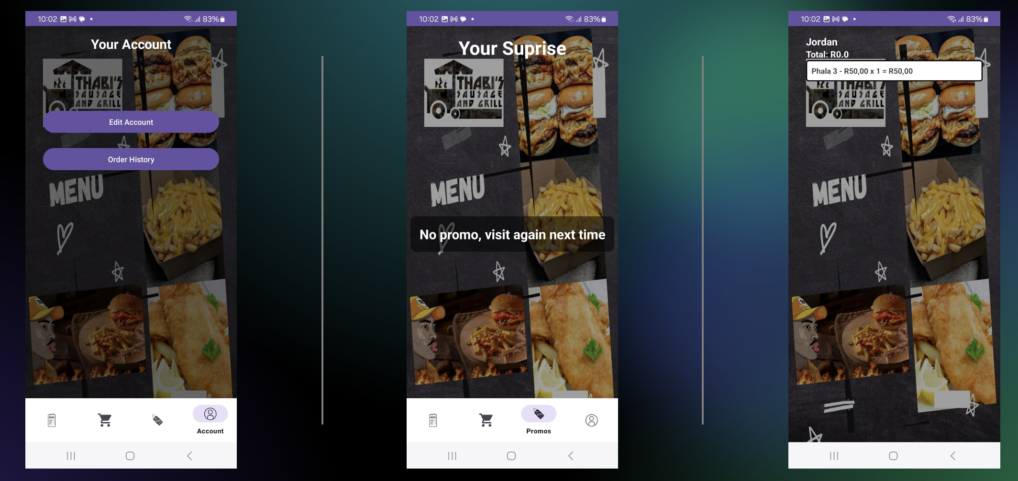

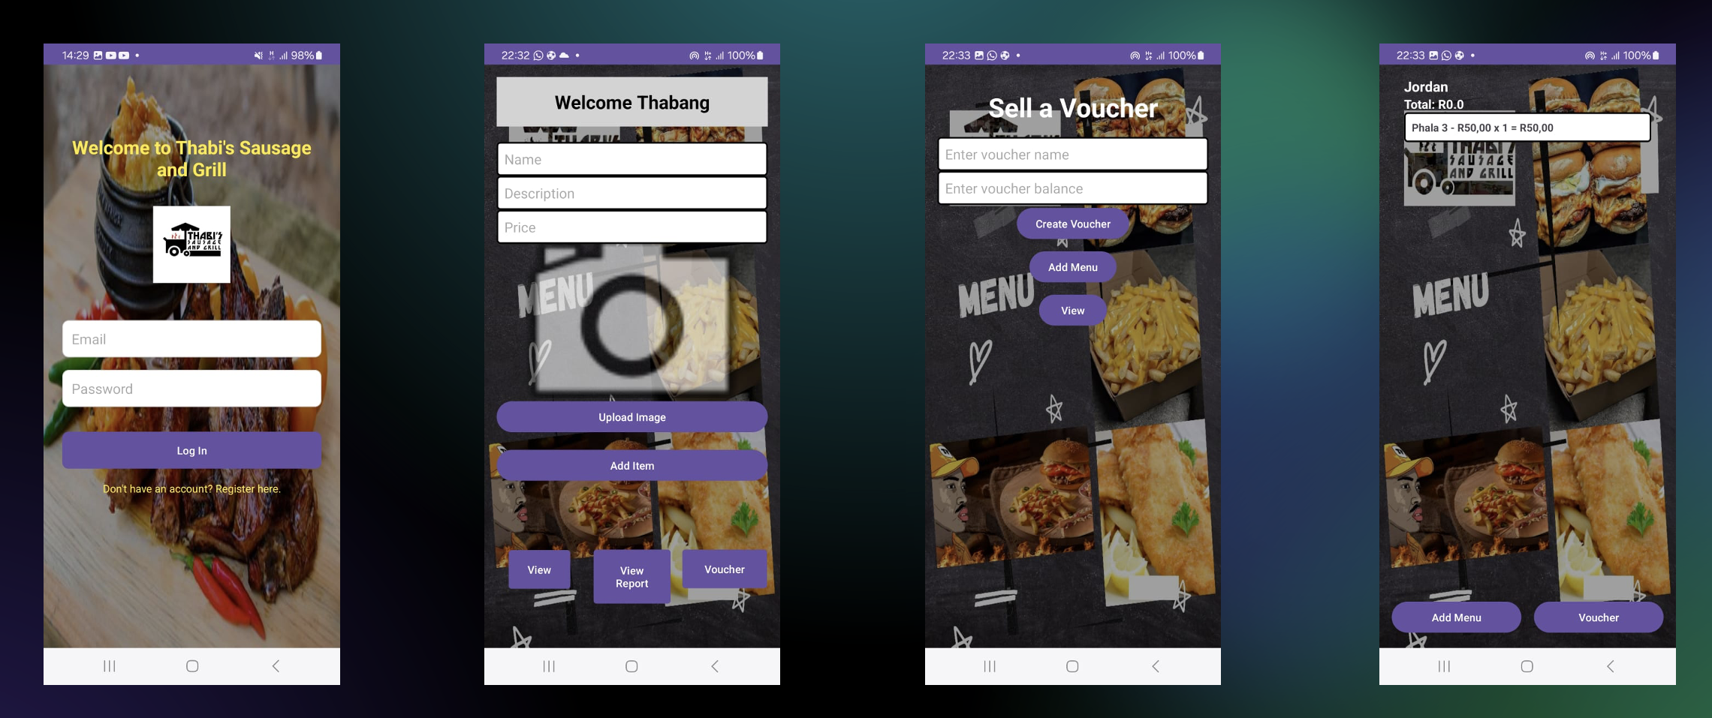

# **Redone Project Brief**





# **Azure DevOps implementation**

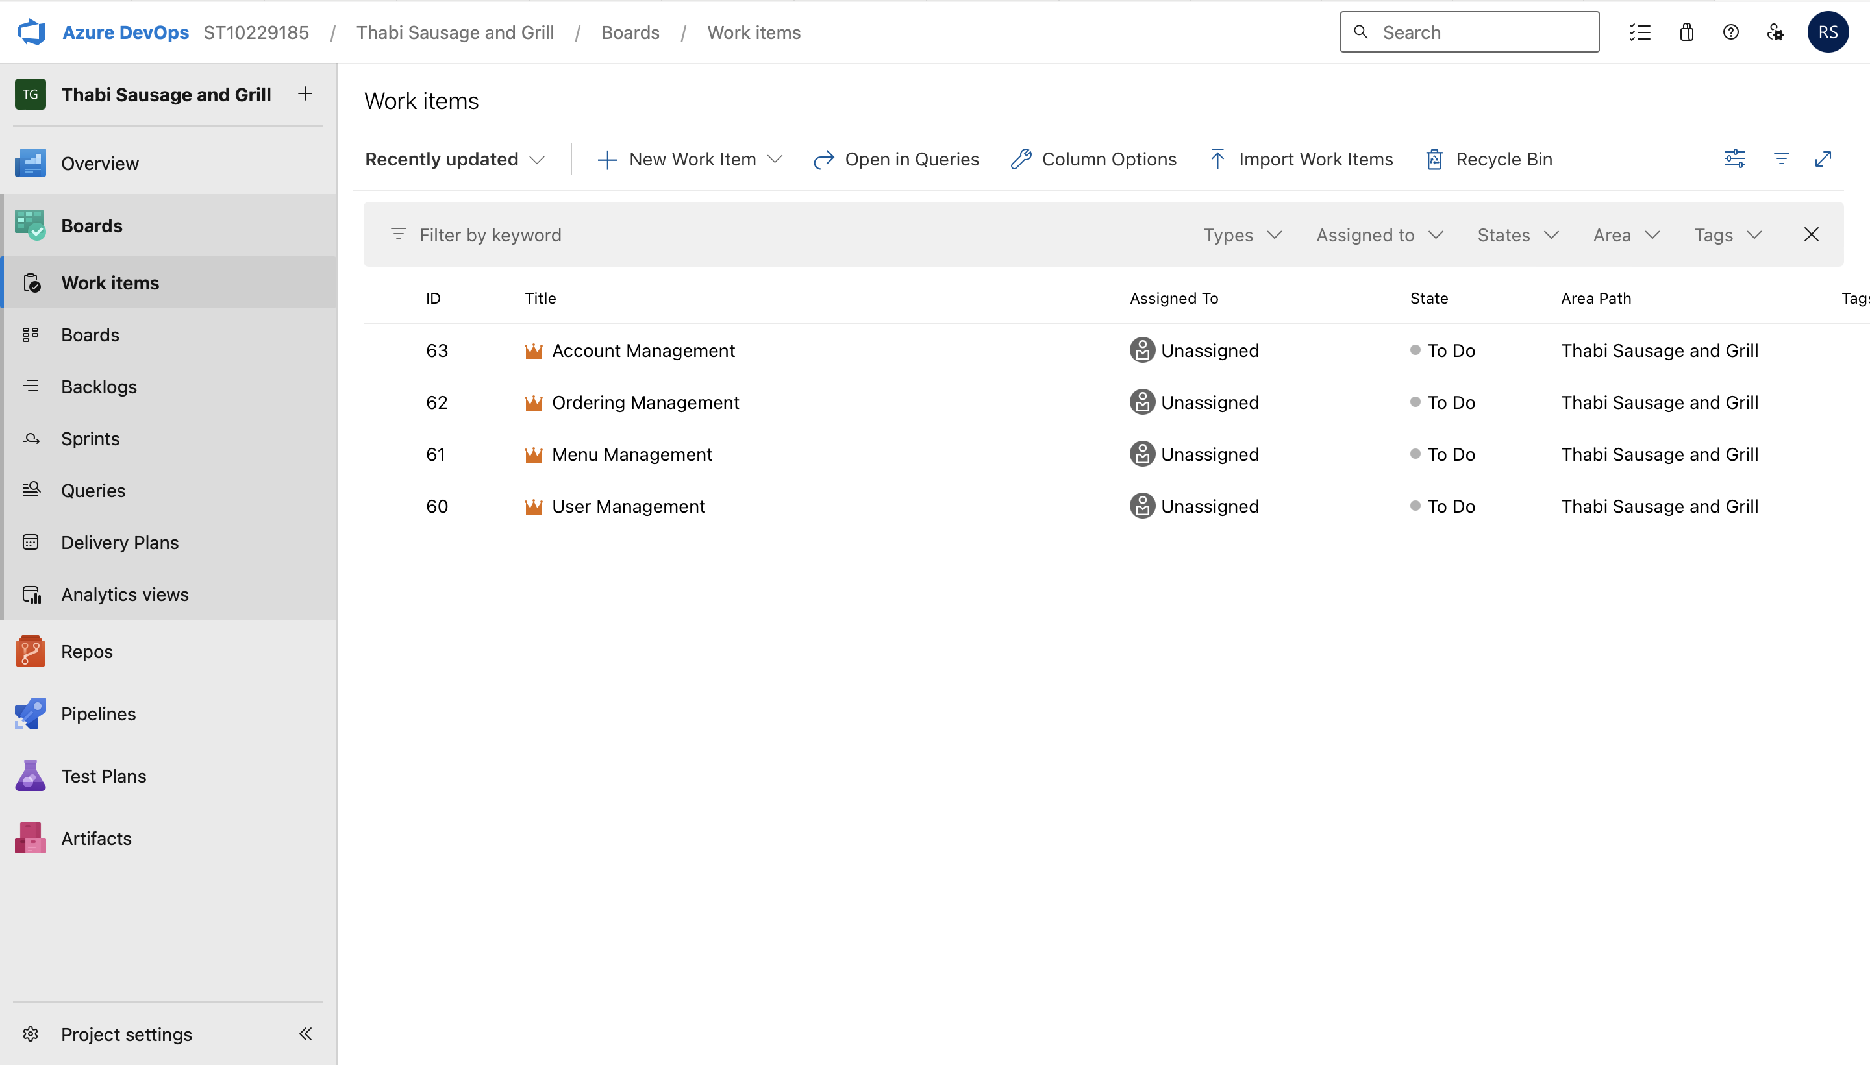

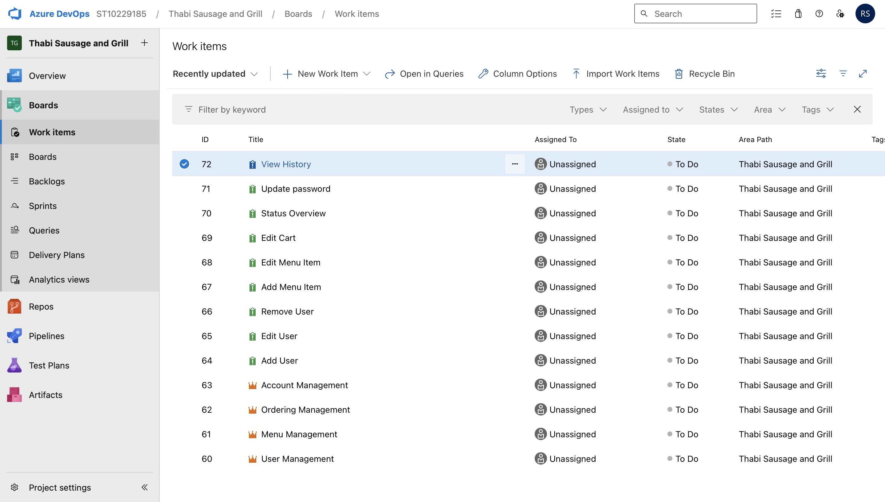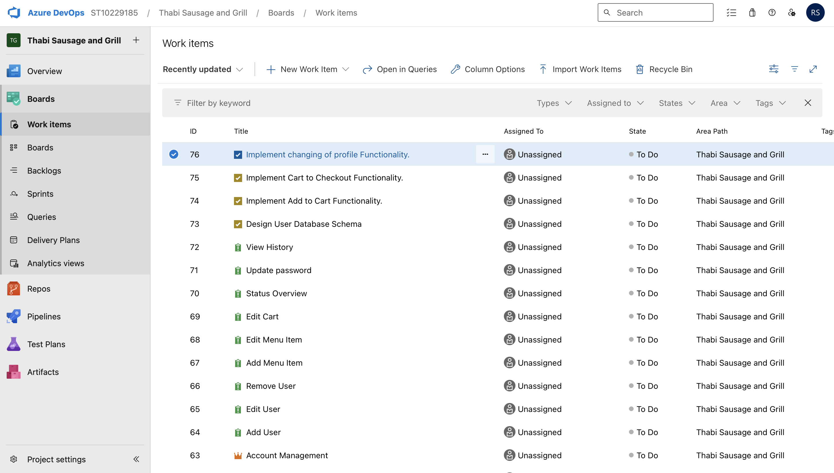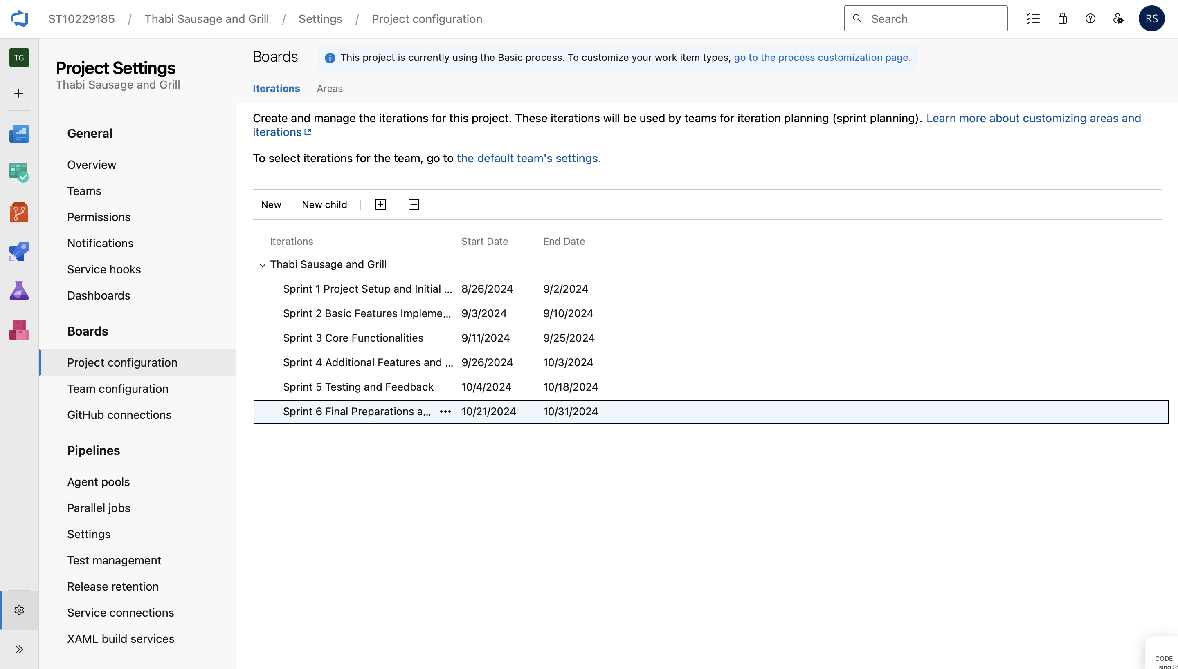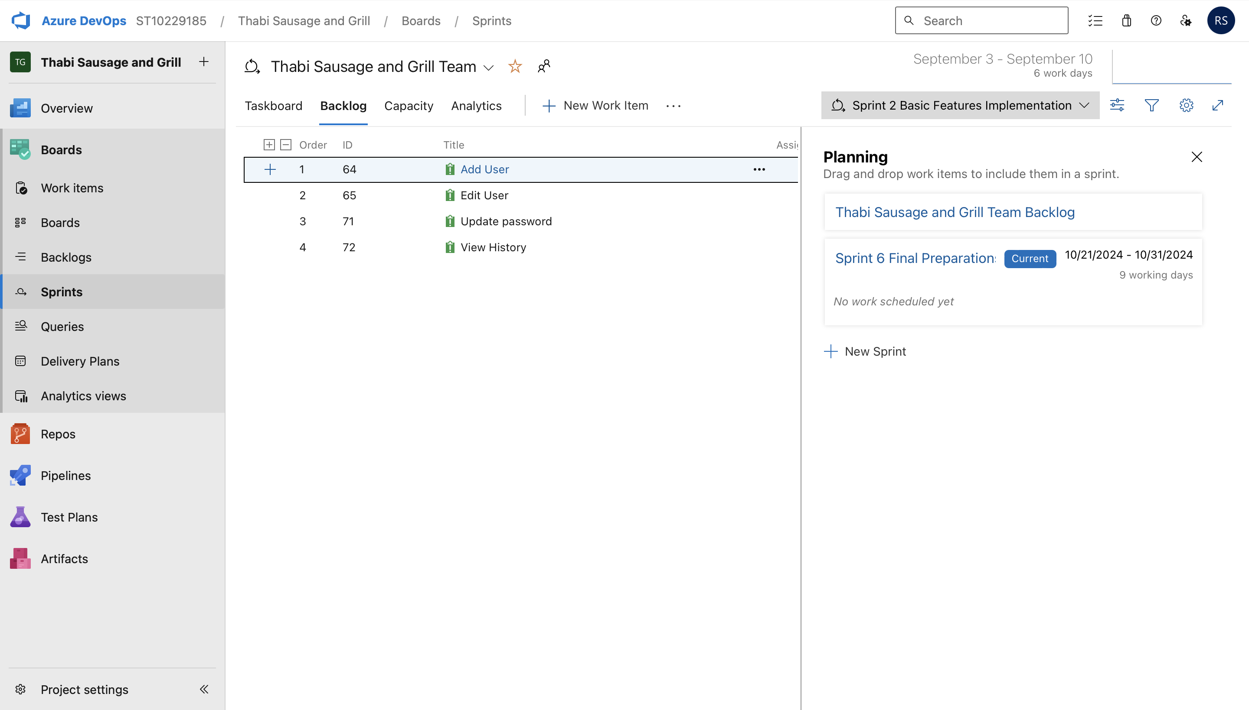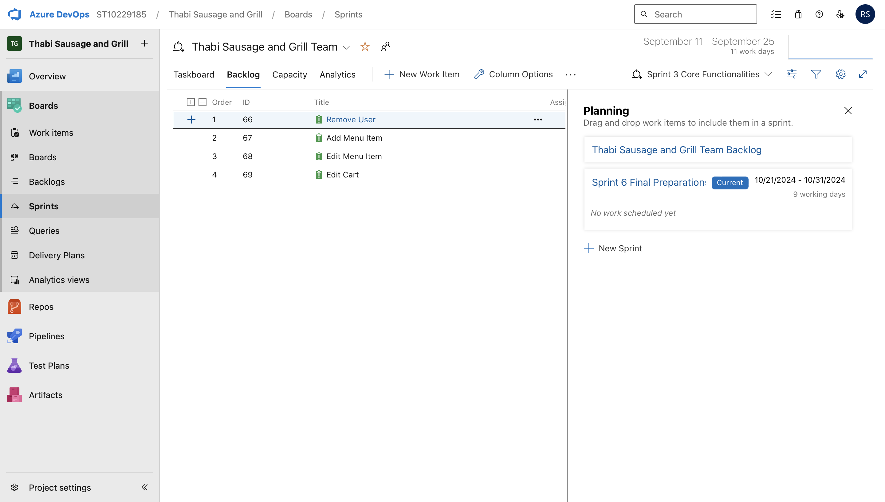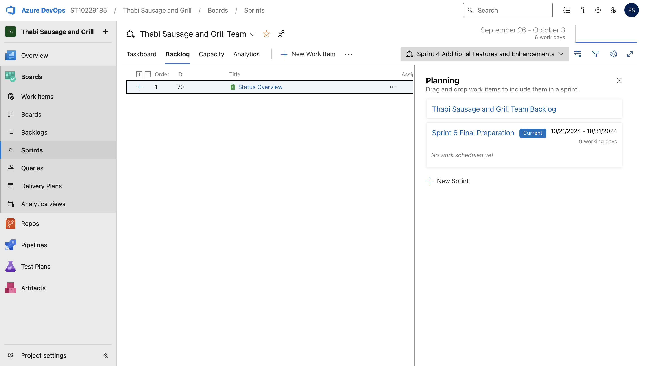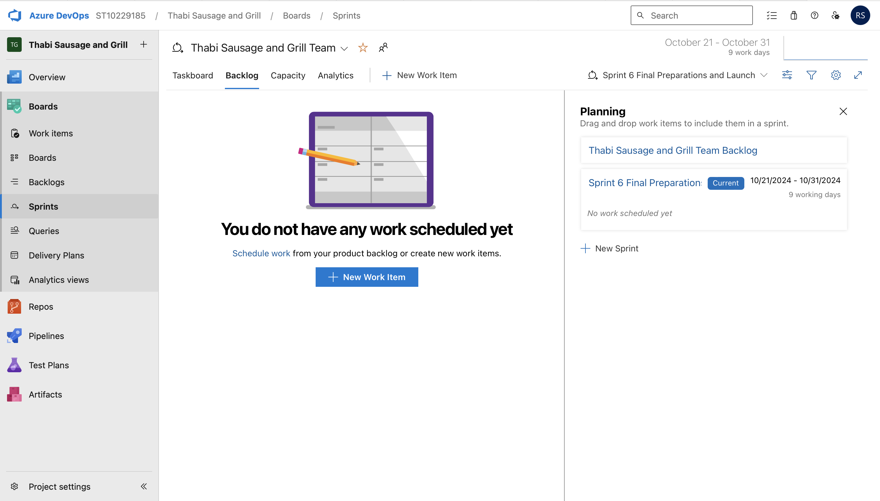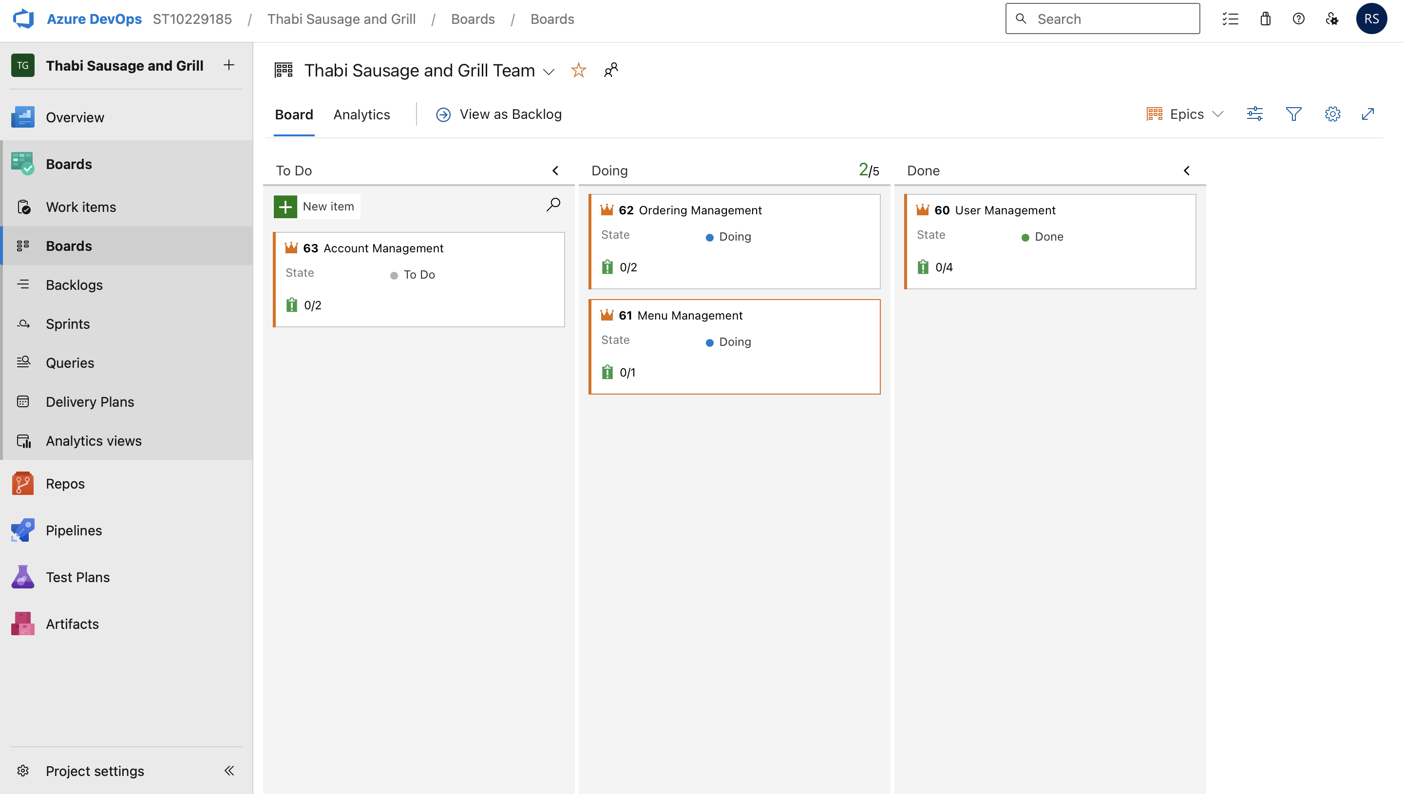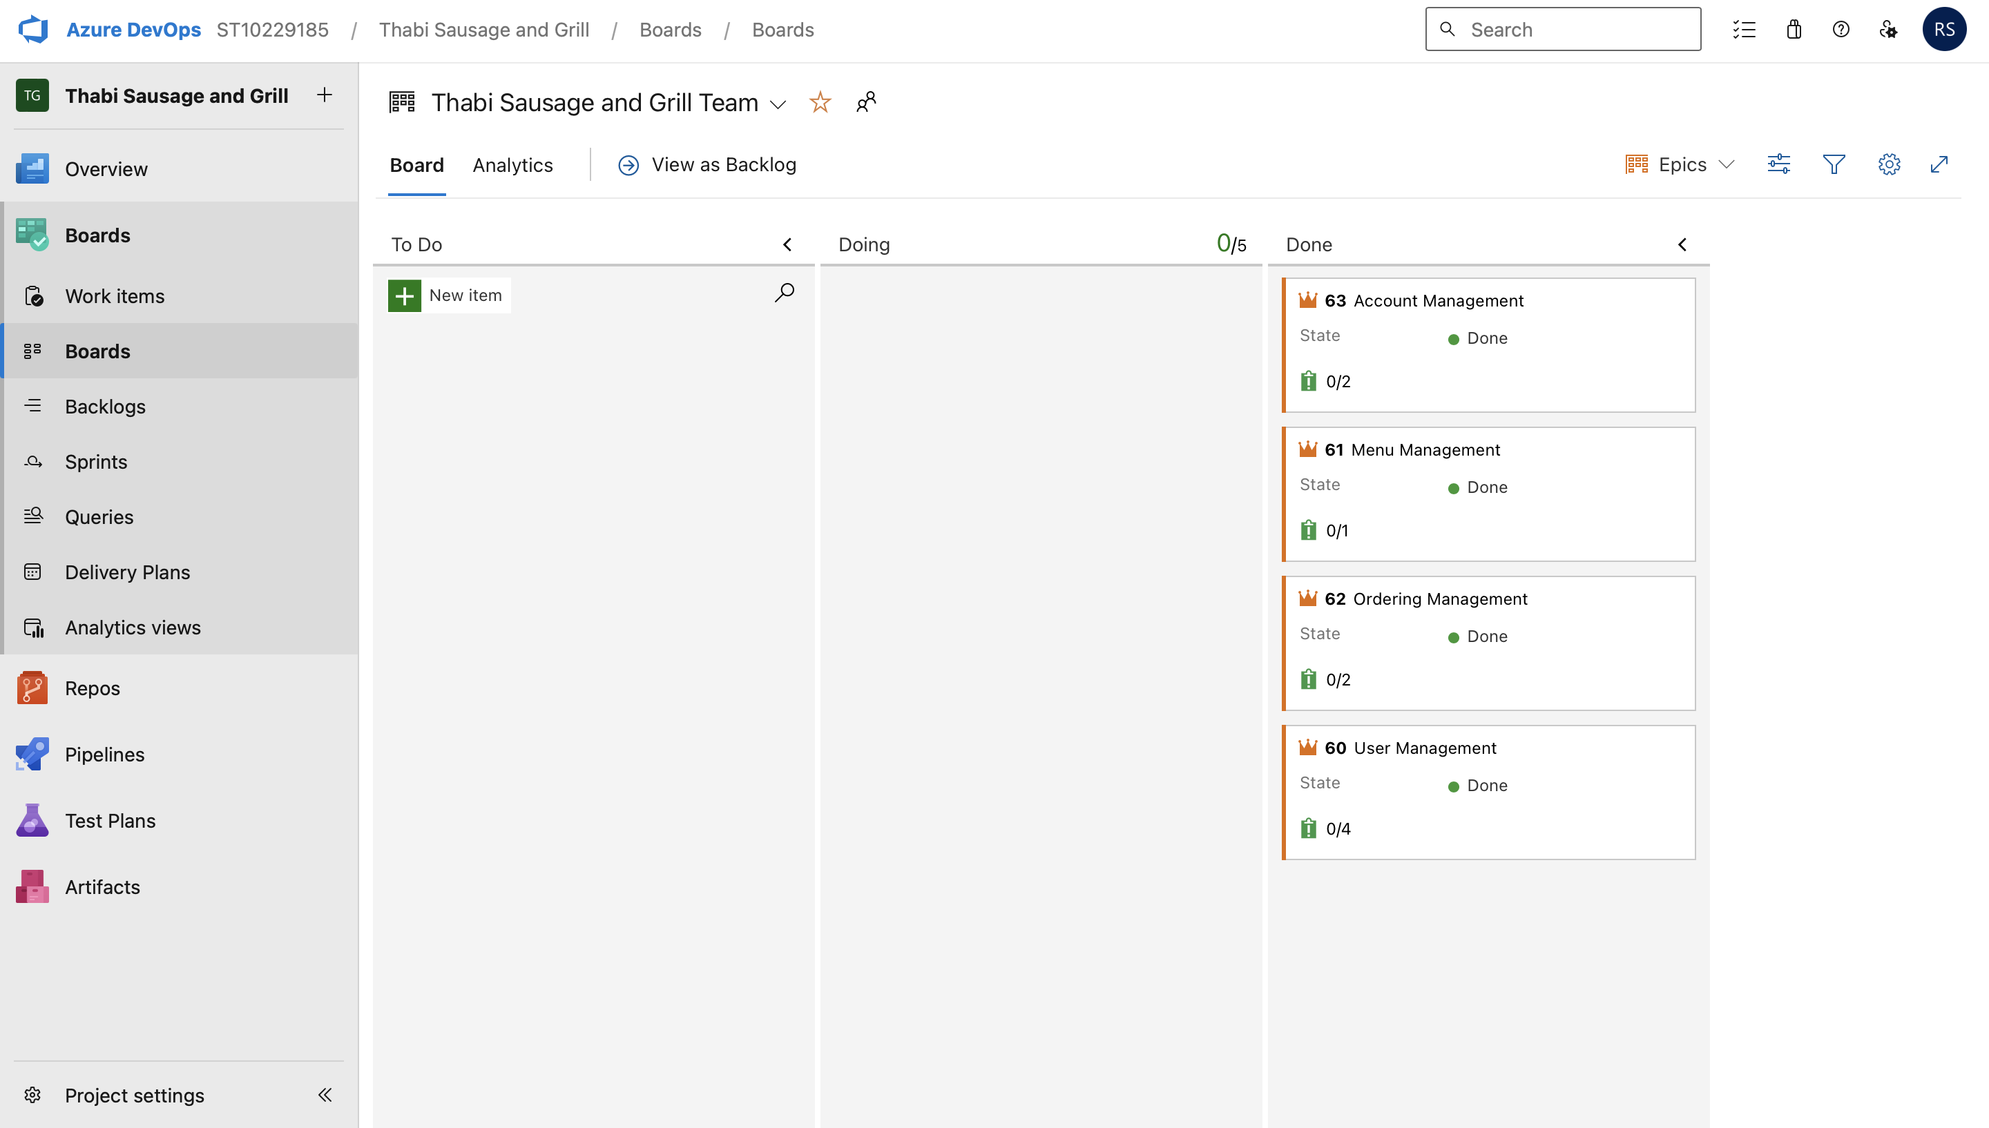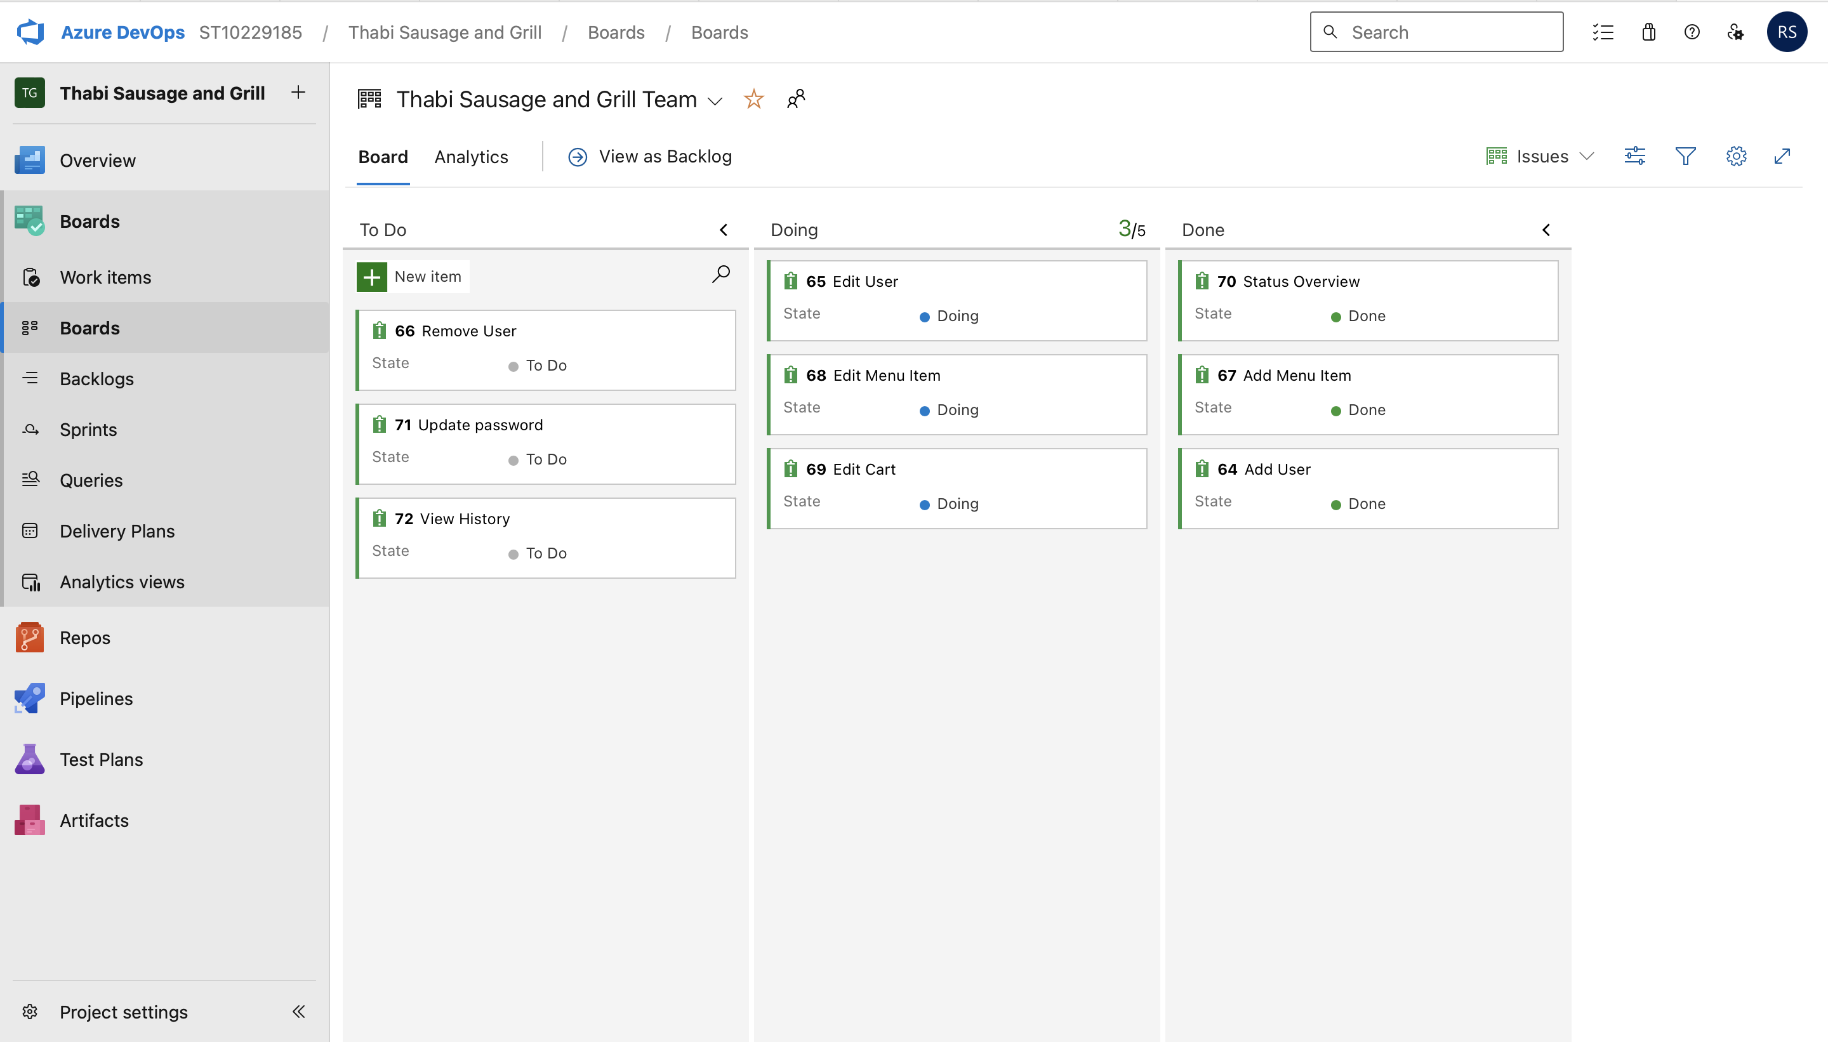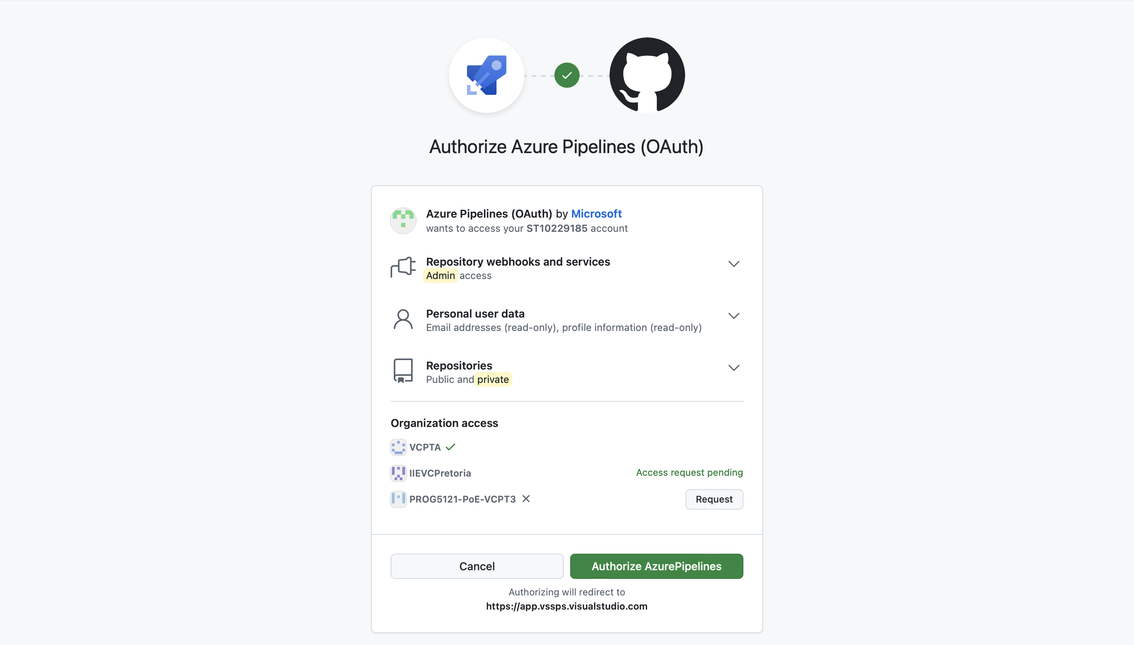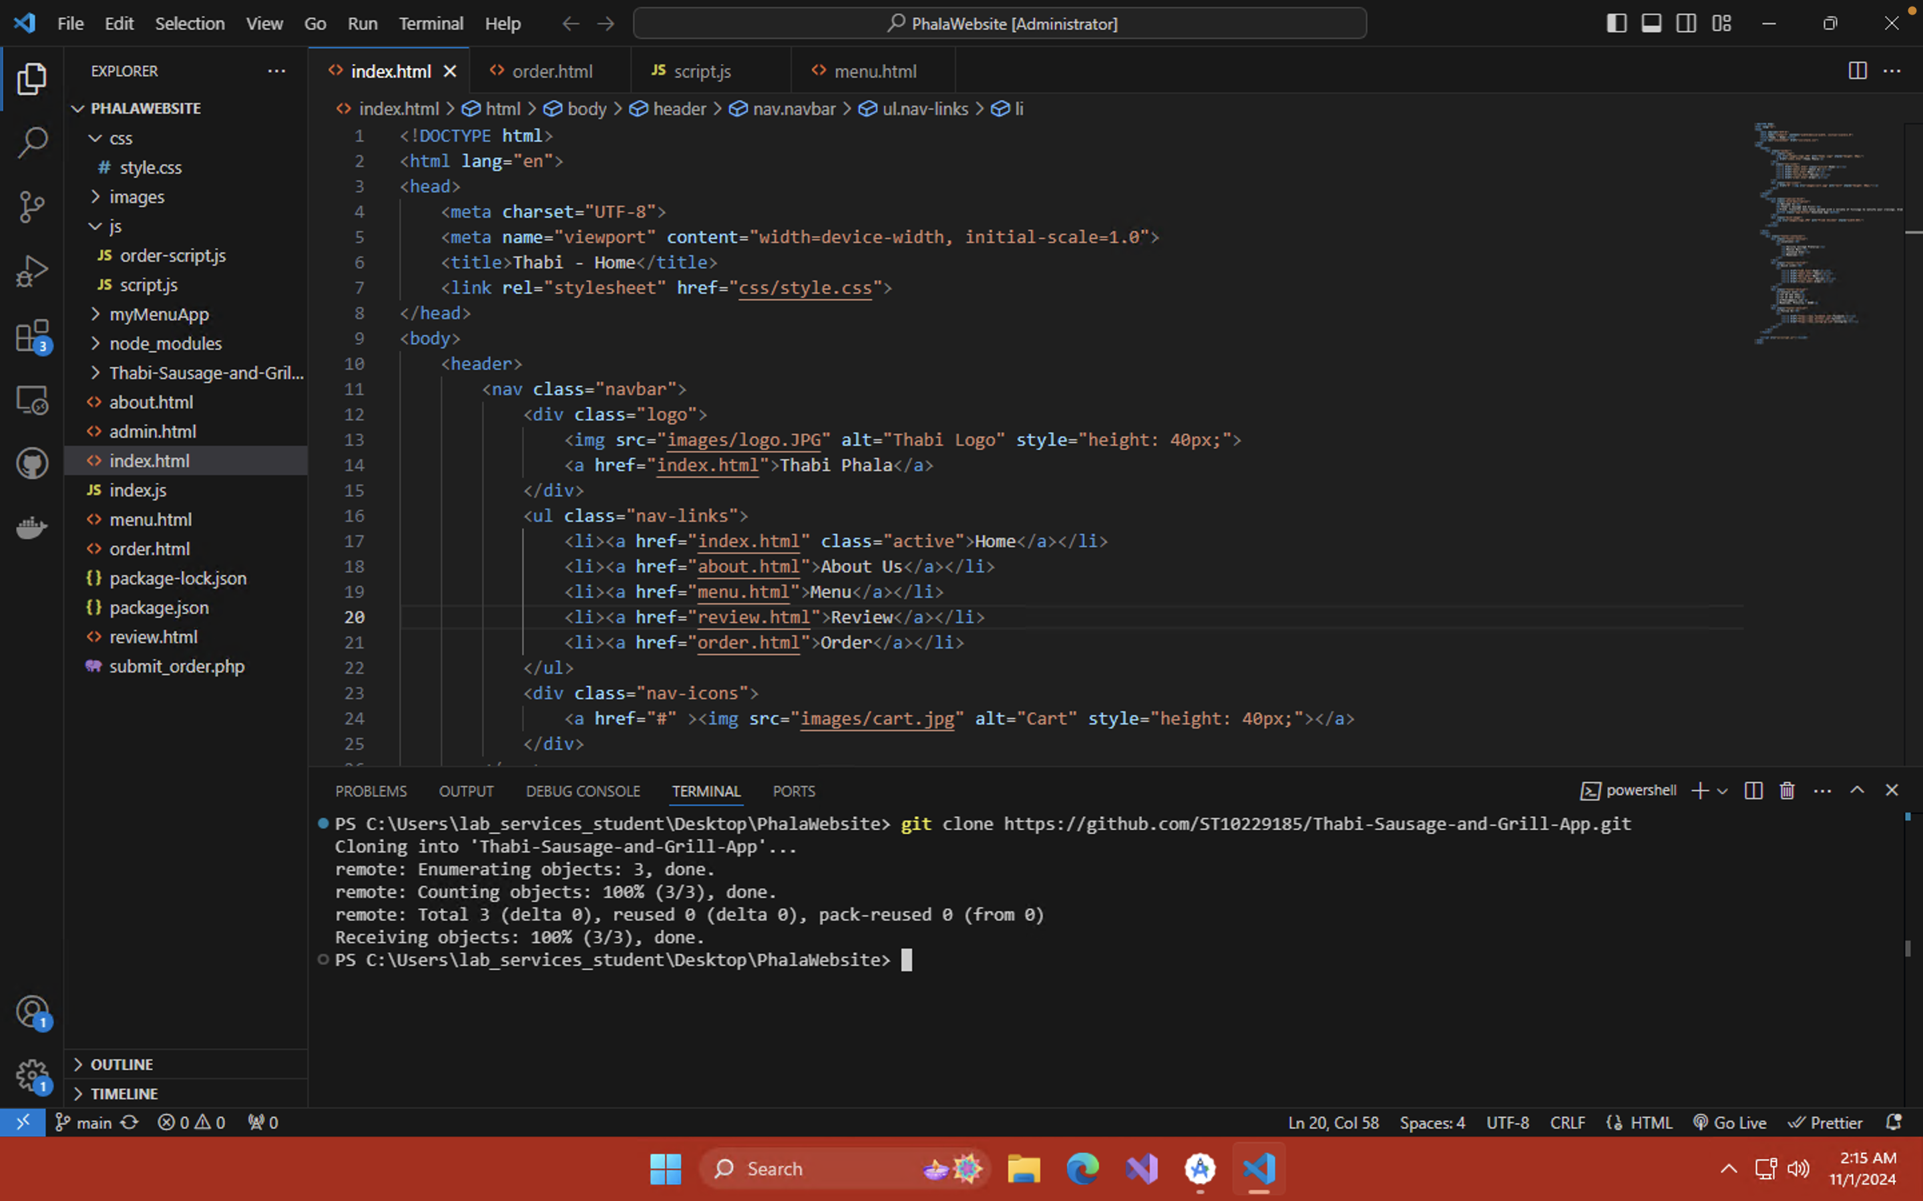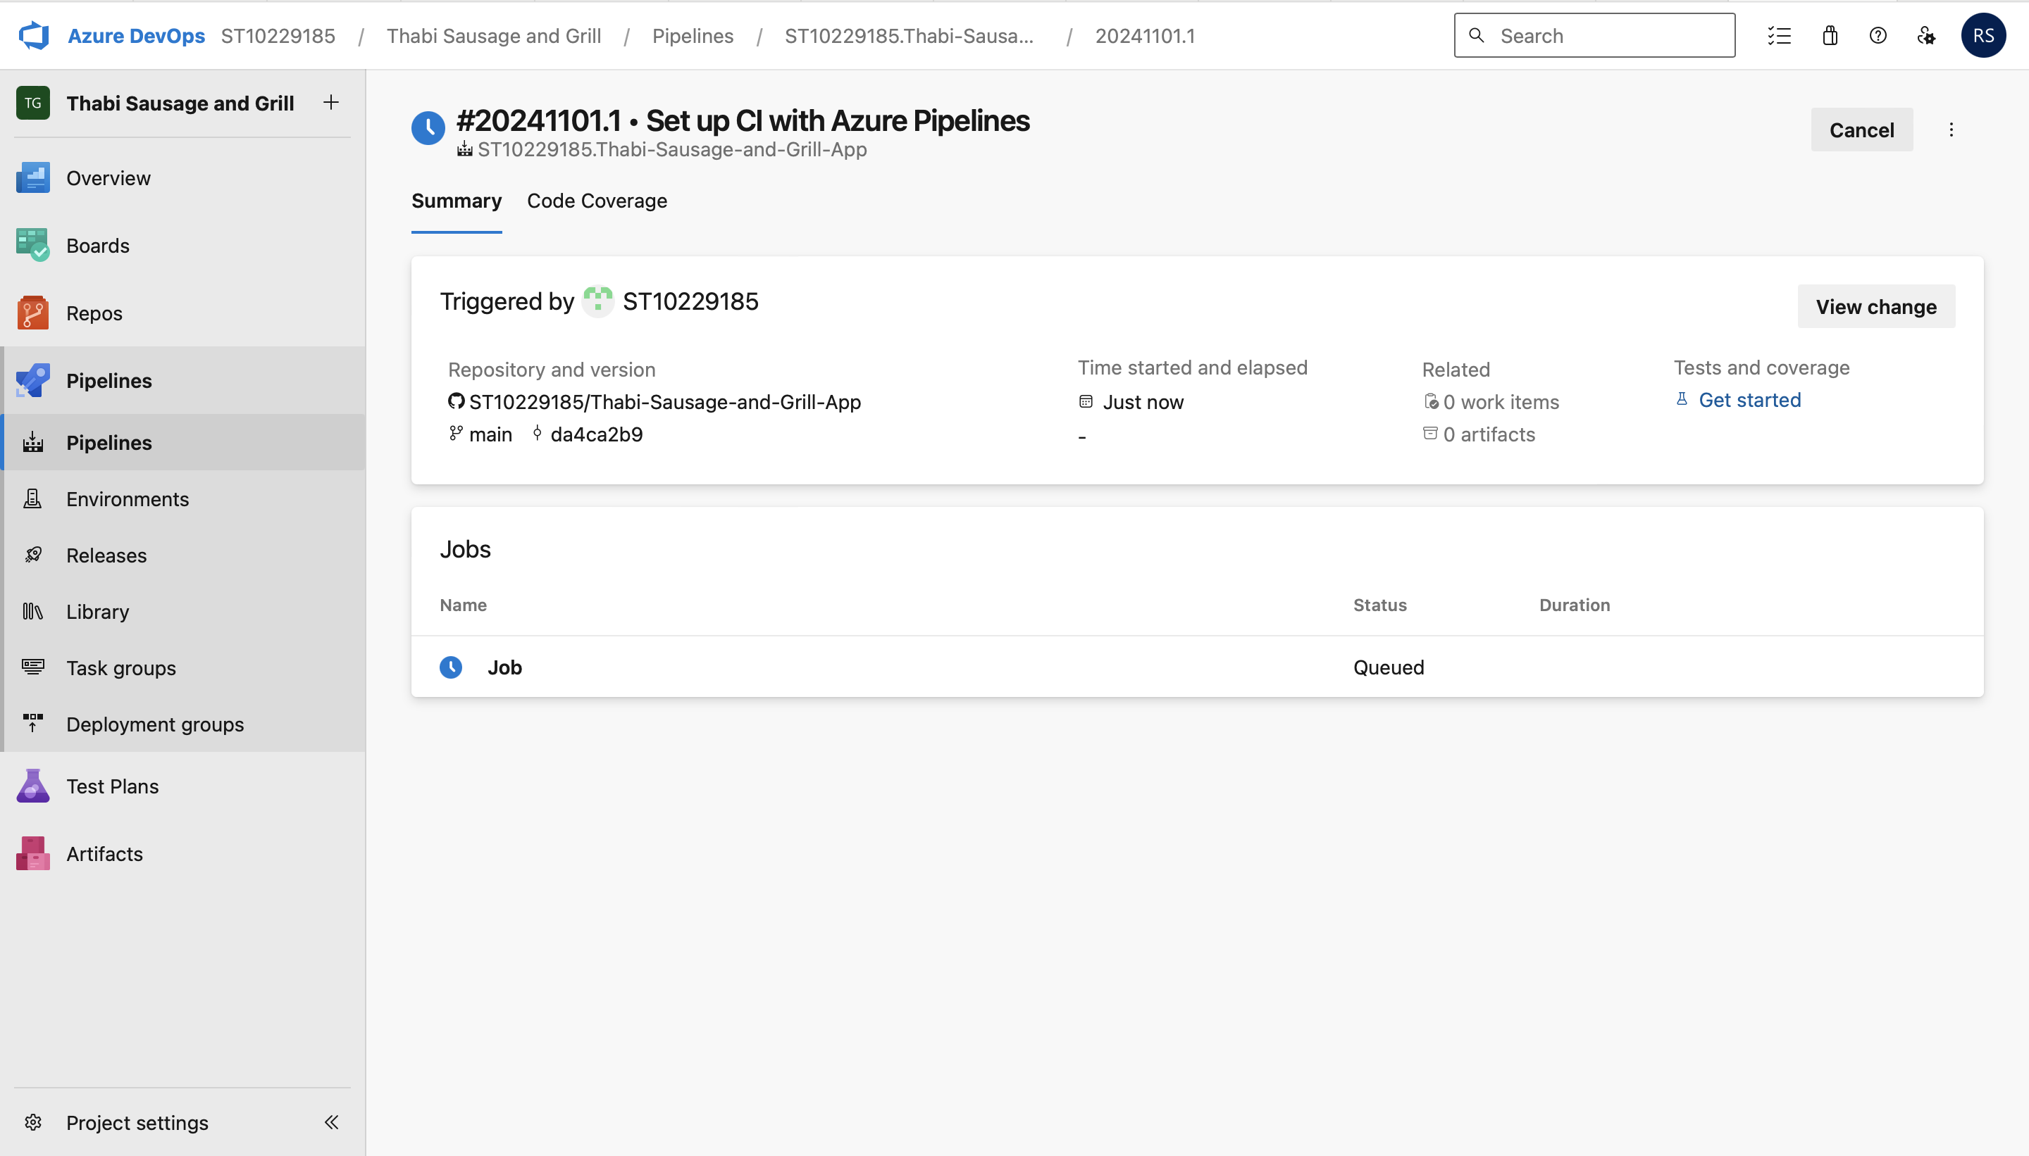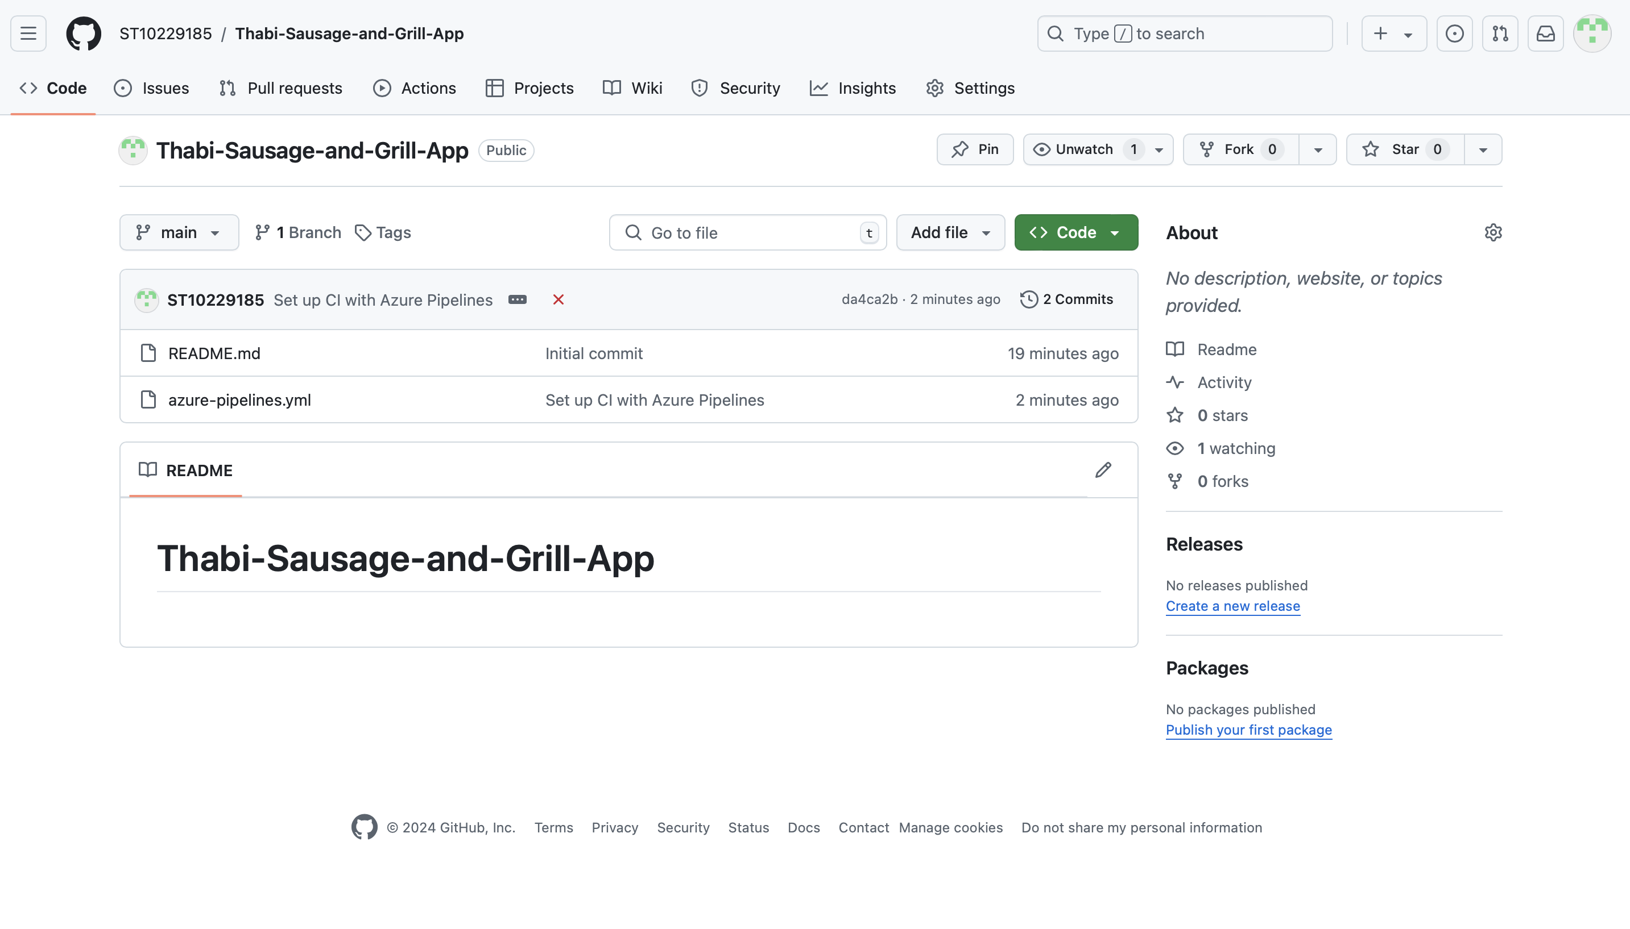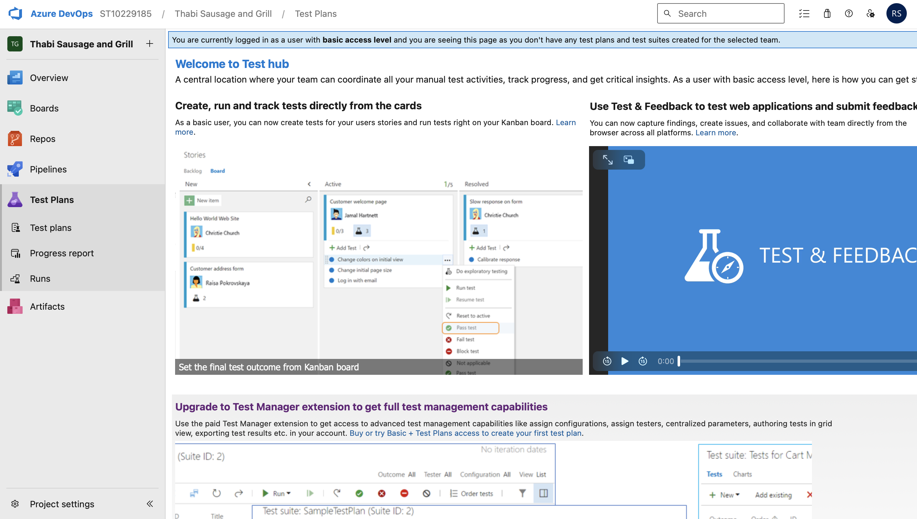

# **GitHub** **implementation**

Git Hub Link : https://github.com/ST10229185/Thabi-Sausage-and-Grill-App